






Read and interpret basic instructions, directions and/or diagrams
D1.LAN.CL10.08
Trainer Guide

Read and interpret basic instructions, directions and/or diagrams

D1.LAN.CL10.08

Trainer Guide




Project Base
William Angliss Institute of TAFE
555 La Trobe Street
Melbourne 3000 Victoria
Telephone: | (03) 9606 2111
Facsimile: | (03) 9670 1330
Acknowledgements
Project Director: | Wayne Crosbie
Chief Writer: | Alan Hickman
Subject Writer: | Quentin Derrick
Project Manager/Editor: | Alan Maguire
DTP/Production: | Daniel Chee, Mai Vu, Kaly Quach

The Association of Southeast Asian Nations (ASEAN) was established on 8 August 1967. The Member States of the Association are Brunei Darussalam, Cambodia, Indonesia, Lao PDR, Malaysia, Myanmar, Philippines, Singapore, Thailand and Viet Nam.
The ASEAN Secretariat is based in Jakarta, Indonesia.
General Information on ASEAN appears online at the ASEAN Website: www.asean.org.
All text is produced by William Angliss Institute of TAFE for the ASEAN Project on “Toolbox Development for Front Office, Food and Beverage Services and Food Production Divisions”.
This publication is supported by the Australian Government’s aid program through the ASEAN-Australia Development Cooperation Program Phase II (AADCP II).
Copyright: Association of Southeast Asian Nations (ASEAN) 2013.
All rights reserved.
Disclaimer
Every effort has been made to ensure that this publication is free from errors or omissions. However, you should conduct your own enquiries and seek professional advice before relying on any fact, statement or matter contained in this book. The ASEAN Secretariat and William Angliss Institute of TAFE are not responsible for any injury, loss or damage as a result of material included or omitted from this course. Information in this module is current at the time of publication. Time of publication is indicated in the date stamp at the bottom of each page.
Some images appearing in this resource have been purchased from stock photography suppliers Shutterstock and iStockphoto and other third party copyright owners and as such are non-transferable and non-exclusive. Clip arts, font images and illustrations used are from the Microsoft Office Clip Art and Media Library. Some images have been provided by and are the property of William Angliss Institute.
Additional images have been sourced from Flickr and SXC and are used under Creative Commons licence: http://creativecommons.org/licenses/by/2.0/deed.en

File name: TG_Read_&_interpret_basic_instructions_refined





Table of contents
Competency Based Training (CBT) and assessment - An introduction for trainers 1
Competency standard 11
Notes and PowerPoint slides 19
Recommended training equipment 61
Instructions for Trainers for using PowerPoint – Presenter View 63
Appendix – ASEAN acronyms 65

Competency Based Training (CBT) and assessment - An introduction for trainers

Competency
Competency refers to the ability to perform particular tasks and duties to the standard of performance expected in the workplace.
Competency requires the application of specified knowledge, skills and attitudes relevant to effective participation, consistently over time and in the workplace environment.
The essential skills and knowledge are either identified separately or combined.
Knowledge identifies what a person needs to know to perform the work in an informed and effective manner.
Skills describe the application of knowledge to situations where understanding is converted into a workplace outcome.
Attitude describes the founding reasons behind the need for certain knowledge or why skills are performed in a specified manner.
Competency covers all aspects of workplace performance and involves:
- Performing individual tasks
- Managing a range of different tasks
- Responding to contingencies or breakdowns
- Dealing with the responsibilities of the workplace
- Working with others.

Unit of Competency
Like with any training qualification or program, a range of subject topics are identified that focus on the ability in a certain work area, responsibility or function.
Each manual focuses on a specific unit of competency that applies in the hospitality workplace.
In this manual a unit of competency is identified as a ‘unit’.
Each unit of competency identifies a discrete workplace requirement and includes:
- Knowledge and skills that underpin competency
- Language, literacy and numeracy
- Occupational safety and health requirements.
Each unit of competency must be adhered to in training and assessment to ensure consistency of outcomes.

Element of Competency
An element of competency describes the essential outcomes within a unit of competency.
The elements of competency are the basic building blocks of the unit of competency. They describe in terms of outcomes the significant functions and tasks that make up the competency.
In this manual elements of competency are identified as an ‘element’.

Performance criteria
Performance criteria indicate the standard of performance that is required to demonstrate achievement within an element of competency. The standards reflect identified industry skill needs.
Performance criteria will be made up of certain specified skills, knowledge and attitudes.

Learning
For the purpose of this manual learning incorporates two key activities:
- Training
- Assessment.
Both of these activities will be discussed in detail in this introduction.
Today training and assessment can be delivered in a variety of ways. It may be provided to participants:
- On-the-job – in the workplace
- Off-the-job – at an educational institution or dedicated training environment
- As a combination of these two options.
No longer is it necessary for learners to be absent from the workplace for long periods of time in order to obtain recognised and accredited qualifications.

Learning Approaches
This manual will identify two avenues to facilitate learning:
Competency Based Training (CBT)
This is the strategy of developing a participant’s competency.
Educational institutions utilise a range of training strategies to ensure that participants are able to gain the knowledge and skills required for successful:
- Completion of the training program or qualification
- Implementation in the workplace.
The strategies selected should be chosen based on suitability and the learning styles of participants.

Competency Based Assessment (CBA)
This is the strategy of assessing competency of a participant.
Educational institutions utilise a range of assessment strategies to ensure that participants are assessed in a manner that demonstrates validity, fairness, reliability, flexibility and fairness of assessment processes.

Flexibility in Learning
It is important to note that flexibility in training and assessment strategies is required to meet the needs of participants who may have learning difficulties. The strategies used will vary, taking into account the needs of individual participants with learning difficulties. However they will be applied in a manner which does not discriminate against the participant or the participant body as a whole.
Catering for Participant Diversity
Participants have diverse backgrounds, needs and interests. When planning training and assessment activities to cater for individual differences, trainers and assessors should:
- Consider individuals’ experiences, learning styles and interests
- Develop questions and activities that are aimed at different levels of ability
- Modify the expectations for some participants
- Provide opportunities for a variety of forms of participation, such as individual, pair and small group activities
- Assess participants based on individual progress and outcomes.
The diversity among participants also provides a good reason for building up a learning community in which participants support each other’s learning.
Participant Centred Learning
This involves taking into account structuring training and assessment that:
- Builds on strengths – Training environments need to demonstrate the many positive features of local participants (such as the attribution of academic success to effort, and the social nature of achievement motivation) and of their trainers (such as a strong emphasis on subject disciplines and moral responsibility). These strengths and uniqueness of local participants and trainers should be acknowledged and treasured
- Acknowledges prior knowledge and experience – The learning activities should be planned with participants’ prior knowledge and experience in mind
- Understands learning objectives – Each learning activity should have clear learning objectives and participants should be informed of them at the outset. Trainers should also be clear about the purpose of assignments and explain their significance to participants
- Teaches for understanding – The pedagogies chosen should aim at enabling participants to act and think flexibly with what they know
- Teaches for independent learning – Generic skills and reflection should be nurtured through learning activities in appropriate contexts of the curriculum. Participants should be encouraged to take responsibility for their own learning
- Enhances motivation – Learning is most effective when participants are motivated. Various strategies should be used to arouse the interest of participants
- Makes effective use of resources – A variety of teaching resources can be employed as tools for learning
- Maximises engagement – In conducting learning activities, it is important for the minds of participants to be actively engaged
- Aligns assessment with learning and teaching – Feedback and assessment should be an integral part of learning and teaching
- Caters for learner diversity – Trainers should be aware that participants have different characteristics and strengths and try to nurture these rather than impose a standard set of expectations.
Active Learning
The goal of nurturing independent learning in participants does not imply that they always have to work in isolation or solely in a classroom. On the contrary, the construction of knowledge in tourism and hospitality studies can often best be carried out in collaboration with others in the field. Sharing experiences, insights and views on issues of common concern, and working together to collect information through conducting investigative studies in the field (active learning) can contribute a lot to their eventual success.
Active learning has an important part to play in fostering a sense of community in the class. First, to operate successfully, a learning community requires an ethos of acceptance and a sense of trust among participants, and between them and their trainers. Trainers can help to foster acceptance and trust through encouragement and personal example, and by allowing participants to take risks as they explore and articulate their views, however immature these may appear to be. Participants also come to realise that their classmates (and their trainers) are partners in learning and solving.
Trainers can also encourage cooperative learning by designing appropriate group learning tasks, which include, for example, collecting background information, conducting small-scale surveys, or producing media presentations on certain issues and themes. Participants need to be reminded that, while they should work towards successful completion of the field tasks, developing positive peer relationships in the process is an important objective of all group work.

Competency Based Training (CBT)
Principle of Competency Based Training
Competency based training is aimed at developing the knowledge, skills and attitudes of participants, through a variety of training tools.
Training Strategies
The aims of this curriculum are to enable participants to:
- Undertake a variety of subject courses that are relevant to industry in the current environment
- Learn current industry skills, information and trends relevant to industry
- Learn through a range of practical and theoretical approaches
- Be able to identify, explore and solve issues in a productive manner
- Be able to become confident, equipped and flexible managers of the future
- Be ‘job ready’ and a valuable employee in the industry upon graduation of any qualification level.
To ensure participants are able to gain the knowledge and skills required to meet competency in each unit of competency in the qualification, a range of training delivery modes are used.
Types of Training
In choosing learning and teaching strategies, trainers should take into account the practical, complex and multi-disciplinary nature of the subject area, as well as their participant’s prior knowledge, learning styles and abilities.
Training outcomes can be attained by utilising one or more delivery methods:
Lecture/Tutorial
This is a common method of training involving transfer of information from the trainer to the participants. It is an effective approach to introduce new concepts or information to the learners and also to build upon the existing knowledge. The listener is expected to reflect on the subject and seek clarifications on the doubts.
Demonstration
Demonstration is a very effective training method that involves a trainer showing a participant how to perform a task or activity. Through a visual demonstration, trainers may also explain reasoning behind certain actions or provide supplementary information to help facilitate understanding.
Group Discussions
Brainstorming in which all the members in a group express their ideas, views and opinions on a given topic, is a free flow and exchange of knowledge among the participants and the trainer. The discussion is carried out by the group on the basis of their own experience, perceptions and values. This will facilitate acquiring new knowledge. When everybody is expected to participate in the group discussion, even the introverted persons will also get stimulated and try to articulate their feelings.
The ideas that emerge in the discussions should be noted down and presentations are to be made by the groups. Sometimes consensus needs to be arrived at on a given topic. Group discussions are to be held under the moderation of a leader guided by the trainer. Group discussion technique triggers thinking process, encourages interactions and enhances communication skills.
Role Play
This is a common and very effective method of bringing into the classroom real life situations, which may not otherwise be possible. Participants are made to enact a particular role so as to give a real feel of the roles they may be called upon to play. This enables participants to understand the behaviour of others as well as their own emotions and feelings. The instructor must brief the role players on what is expected of them. The role player may either be given a ready-made script, which they can memorise and enact, or they may be required to develop their own scripts around a given situation. This technique is extremely useful in understanding creative selling techniques and human relations. It can be entertaining and energising and it helps the reserved and less literate to express their feelings.

Simulation Games
When trainees need to become aware of something that they have not been conscious of, simulations can be a useful mechanism. Simulation games are a method based on "here and now" experience shared by all the participants. The games focus on the participation of the trainees and their willingness to share their ideas with others. A "near real life" situation is created providing an opportunity to which they apply themselves by adopting certain behaviour. They then experience the impact of their behaviour on the situation. It is carried out to generate responses and reactions based on the real feelings of the participants, which are subsequently analysed by the trainer.
While use of simulation games can result in very effective learning, it needs considerable trainer competence to analyse the situations.
Individual /Group Exercises
Exercises are often introduced to find out how much the participant has assimilated. This method involves imparting instructions to participants on a particular subject through use of written exercises. In the group exercises, the entire class is divided into small groups, and members are asked to collaborate to arrive at a consensus or solution to a problem.
Case Study
This is a training method that enables the trainer and the participant to experience a real life situation. It may be on account of events in the past or situations in the present, in which there may be one or more problems to be solved and decisions to be taken. The basic objective of a case study is to help participants diagnose, analyse and/or solve a particular problem and to make them internalise the critical inputs delivered in the training. Questions are generally given at the end of the case study to direct the participants and to stimulate their thinking towards possible solutions. Studies may be presented in written or verbal form.
Field Visit
This involves a carefully planned visit or tour to a place of learning or interest. The idea is to give first-hand knowledge by personal observation of field situations, and to relate theory with practice. The emphasis is on observing, exploring, asking questions and understanding. The trainer should remember to brief the participants about what they should observe and about the customs and norms that need to be respected.
Group Presentation
The participants are asked to work in groups and produce the results and findings of their group work to the members of another sub-group. By this method participants get a good picture of each other's views and perceptions on the topic and they are able to compare them with their own point of view. The pooling and sharing of findings enriches the discussion and learning process.
Practice Sessions
This method is of paramount importance for skills training. Participants are provided with an opportunity to practice in a controlled situation what they have learnt. It could be real life or through a make-believe situation.

Games
This is a group process and includes those methods that involve usually fun-based activity, aimed at conveying feelings and experiences, which are everyday in nature, and applying them within the game being played. A game has set rules and regulations, and may or may not include a competitive element. After the game is played, it is essential that the participants be debriefed and their lessons and experiences consolidated by the trainer.
Research
Trainers may require learners to undertake research activities, including online research, to gather information or further understanding about a specific subject area.

Competency Based Assessment (CBA)
Principle of Competency Based Assessment
Competency based assessment is aimed at compiling a list of evidence that shows that a person is competent in a particular unit of competency.
Competencies are gained through a multitude of ways including:
- Training and development programs
- Formal education
- Life experience
- Apprenticeships
- On-the-job experience
- Self-help programs.
All of these together contribute to job competence in a person. Ultimately, assessors and participants work together, through the ‘collection of evidence’ in determining overall competence.
This evidence can be collected:
- Using different formats
- Using different people
- Collected over a period of time.
The assessor, who is ideally someone with considerable experience in the area being assessed, reviews the evidence and verifies the person as being competent or not.
Flexibility in Assessment
Whilst allocated assessment tools have been identified for this subject, all attempts are made to determine competency and suitable alternate assessment tools may be used, according to the requirements of the participant.
The assessment needs to be equitable for all participants, taking into account their cultural and linguistic needs.
Competency must be proven regardless of:
- Language
- Delivery Method
- Assessment Method.
Assessment Objectives
The assessment tools used for subjects are designed to determine competency against the ‘elements of competency’ and their associated ‘performance criteria’.
The assessment tools are used to identify sufficient:
- Knowledge, including underpinning knowledge
- Skills
- Attitudes
Assessment tools are activities that trainees are required to undertake to prove participant competency in this subject.
All assessments must be completed satisfactorily for participants to obtain competence in this subject. There are no exceptions to this requirement, however, it is possible that in some cases several assessment items may be combined and assessed together.
Types of Assessment
Allocated Assessment Tools
There are a number of assessment tools that are used to determine competency in this subject:
- Work projects
- Written questions
- Oral questions
- Third Party Report
- Observation Checklist.
Instructions on how assessors should conduct these assessment methods are explained in the Assessment Manuals.
Alternative Assessment Tools
Whilst this subject has identified assessment tools, as indicated above, this does not restrict the assessor from using different assessment methods to measure the competency of a participant.
Evidence is simply proof that the assessor gathers to show participants can actually do what they are required to do.
Whilst there is a distinct requirement for participants to demonstrate competency, there are many and diverse sources of evidence available to the assessor.
Ongoing performance at work, as verified by a supervisor or physical evidence, can count towards assessment. Additionally, the assessor can talk to customers or work colleagues to gather evidence about performance.
A range of assessment methods to assess competency include:
- Practical demonstrations
- Practical demonstrations in simulated work conditions
- Problem solving
- Portfolios of evidence
- Critical incident reports
- Journals
- Oral presentations
- Interviews
- Videos
- Visuals: slides, audio tapes
- Case studies
- Log books
- Projects
- Role plays
- Group projects
- Group discussions
- Examinations.
Recognition of Prior Learning
Recognition of Prior Learning is the process that gives current industry professionals who do not have a formal qualification, the opportunity to benchmark their extensive skills and experience against the standards set out in each unit of competency/subject.
Also known as a Skills Recognition Audit (SRA), this process is a learning and assessment pathway which encompasses:
- Recognition of Current Competencies (RCC)
- Skills auditing
- Gap analysis and training
- Credit transfer.
Assessing competency
As mentioned, assessment is the process of identifying a participant’s current knowledge, skills and attitudes sets against all elements of competency within a unit of competency. Traditionally in education, grades or marks were given to participants, dependent on how many questions the participant successfully answered in an assessment tool.
Competency based assessment does not award grades, but simply identifies if the participant has the knowledge, skills and attitudes to undertake the required task to the specified standard.
Therefore, when assessing competency, an assessor has two possible results that can be awarded:
- Pass Competent (PC)
- Not Yet Competent (NYC).
Pass Competent (PC)
If the participant is able to successfully answer or demonstrate what is required, to the expected standards of the performance criteria, they will be deemed as ‘Pass Competent’ (PC).
The assessor will award a ‘Pass Competent’ (PC) if they feel the participant has the necessary knowledge, skills and attitudes in all assessment tasks for a unit.
Not Yet Competent’ (NYC)
If the participant is unable to answer or demonstrate competency to the desired standard, they will be deemed to be ‘Not Yet Competent’ (NYC).
This does not mean the participant will need to complete all the assessment tasks again. The focus will be on the specific assessment tasks that were not performed to the expected standards.
The participant may be required to:
a) Undertake further training or instruction
b) Undertake the assessment task again until they are deemed to be ‘Pass Competent’.

Competency standard
UNIT TITLE: READ AND INTERPRET BASIC INSTRUCTIONS, DIRECTIONS AND/OR DIAGRAMS |  |  |  | NOMINAL HOURS: 60
UNIT NUMBER: D1.LAN.CL10.08
UNIT DESCRIPTOR: This unit deals with the skills and knowledge required to read and interpret basic instructions, directions and/or diagrams in a range of settings within the labour divisions of the hotel industries
ELEMENTS AND PERFORMANCE CRITERIA | UNIT VARIABLE AND ASSESSMENT GUIDE
Element 1: Prepare for work  1.1 Read and interpret job specifications from internal and external customers  1.2 Read and interpret procedures  1.3 Read and interpret basic instructions, directions and/or diagrams  1.4 Read and interpret work instructions to determine job requirements  Element 2: Read and interpret information about routine tasks, processes or events  2.1 Identify relevant sources of information/documentation so that job can be performed in accordance with the organisation’s requirements  2.2 Identify the purpose of instructions, directions and/or diagrams for particular jobs | Unit Variables  The Unit Variables provide advice to interpret the scope and context of this unit of competence, allowing for differences between enterprises and workplaces. It relates to the unit as a whole and facilitates holistic assessment  This unit applies to reading and interpreting basic instructions and/or diagrams within the labour divisions of the hotel and travel industries and may include:  - Front Office  - Housekeeping  - Food and Beverage Service  - Food Production  Job specifications may detail:  Outcomes  Duties  Reporting relationships.
2.3 Ask questions from appropriate people to gain additional information and/or to clarify understanding  2.4 Read and interpret relevant details from instructions, directions and/or diagrams for application to particular jobs  Element 3: Receive and respond to basic instructions and directions  3.1 Receive, clarify and assess requirements of instructions and/or directions in accordance with organisational policies and procedures  3.2 Question and confirm assignment instructions and/or directions if necessary  3.3 Comply with directions and or instructions within designated timelines  3.4 Obtain feedback after instructions and/or directions have been complied with | Internal customers may include:  Colleagues working in another department  Team members  Supervisor or managers.  External customers may include:  Suppliers  People who buy the goods and services the enterprise sells.  Procedures may relate to:  Hazard policies and procedures  Emergency, fire and accident procedures  Personal safety procedures  Procedures for the use of personal protective clothing and equipment  Use of motor vehicles  Resolution procedures  Job procedures and work instructions.
Instructions, directions and/or diagrams may include:
Work instructions
Directions on how to use equipment safely
Directions on how to complete a task safely
Diagrams that show safe working procedures
Policies and procedures
Manuals.
Work instructions to determine job requirements may relate to:
Methods of work
Processes or procedures
Equipment
Policies and procedures
Manuals.
Information/documentation may include:
Workplace procedures, checklists and instructions
Goods identification numbers and codes
Manifests, bar codes, goods and container identification
Manufacturer's specifications
Workplace policies
Supplier and/or client instructions
Material safety data sheets
Relevant codes of practice, including the national standards for manual handling and the industry safety code
Legislation, regulations and related documentation
Award, enterprise bargaining agreement, other industrial arrangements
Standards and certification requirements
Quality assurance procedures
Emergency procedures.
Appropriate people may include:
Supervisors, managers
Colleagues
Human resource personnel
Members of the public
Clients.
Instructions and/or directions may relate to:
Letters
Memos
Faxes
Emails
Invoices and purchase orders
Policies and procedures
Manuals.
Assignment instructions and/or directions may relate to:
Instructions from client/supervisor/management
Assignment objectives and timeframes
Work tasks and procedures
Resource and equipment requirements
Reporting and documentation requirements
Personal protective clothing and equipment requirements.
Feedback may include:
Formal feedback:
- 360 degree assessment
- Customer satisfaction surveys/forms
- Team evaluations
- Performance reviews/appraisals
- Workplace assessment
Informal feedback may include:
- Critical incident reviews
- Impromptu questioning of customers to obtain view of products and/or service provided
- Chance discussions with customers
- Coaching and mentoring
- Seeking the opinions of others
- Comments from supervisors, colleagues or clients
- Personal, reflective behaviour strategies.
Assessment Guide
Assessment must confirm knowledge and skills:
Knowledge about and ability to interpret signs and symbols relevant to workplace functions
Ability to locate, interpret and apply relevant information
Knowledge of and ability to interpret legislation, regulations, policies, procedures and guidelines relating to workplace.
Linkages To Other Units
Perform clerical procedures
Work effectively with colleagues and customers
Work in a socially diverse environment
Respond to instructions given in English
Follow safety and security procedures
Manage and resolve conflict situations.
Critical Aspects of Assessment
Evidence of the following is essential:
Demonstrated ability to identify information about routine tasks, processes, events or skills
Demonstrated ability to locate, interpret and apply relevant information
Demonstrated ability to read and interpret basic instructions, directions and/or diagrams to achieve appropriate work outcomes
Demonstrated ability to read and interpret signs and symbols relevant to workplace functions.
Context of Assessment
This unit may be assessed on or off the job
Assessment should include practical demonstration of the ability to read and interpret basic instructions, directions and/or diagrams either in the workplace or through a simulation activity, supported by a range of methods to assess underpinning knowledge
Assessment must relate to the individual’s work area or area of responsibility
Assessment must include project or work activities that allow the candidate to respond to multiple and varying work instructions and/or directions relevant to work area, job role and area of responsibility.
Resource Implications
Training and assessment to include access to a real or simulated workplace; and access to workplace standards, procedures, policies, guidelines, tools and equipment.
Assessment Methods
The following methods may be used to assess competency for this unit:
Case studies
Observation of practical candidate performance
Oral and written questions
Portfolio evidence
Problem solving
Role plays
Third party reports completed by a supervisor
Project and assignment work.
Key Competencies in this Unit
Level 1 = competence to undertake tasks effectively
Level 2 = competence to manage tasks
Level 3 = competence to use concepts for evaluating
 | Key Competencies | Level | Examples
 | Collecting, organising and analysing information | 1 | Gather relevant information together
 | Communicating ideas and information | 2 | Communicate with others to ensure a common understanding of the instruction and/or direction
 | Planning and organising activities | 1 | Plan activities to comply with instructions
 | Working with others and in teams | 2 | Respond to internal and external customer instructions and/or directions
 | Using mathematical ideas and techniques | 0
 | Solving problems | 2 | Apply conflict resolution and communication skills to resolve conflict and/or misunderstandings
 | Using technology | 0

Notes and PowerPoint slides
Slide
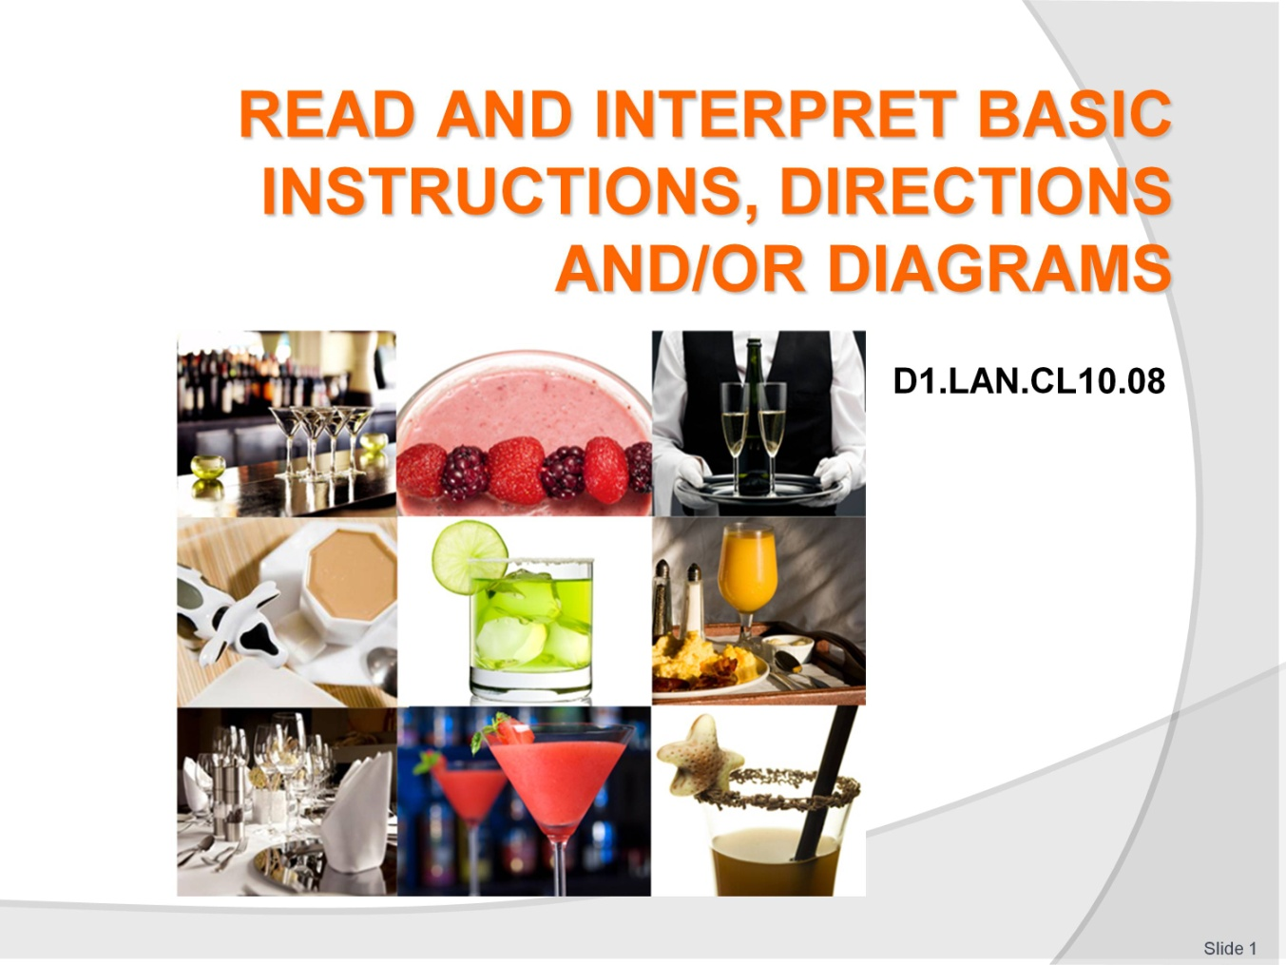
Slide No | Trainer Notes
 | Trainer welcomes the class.

Slide
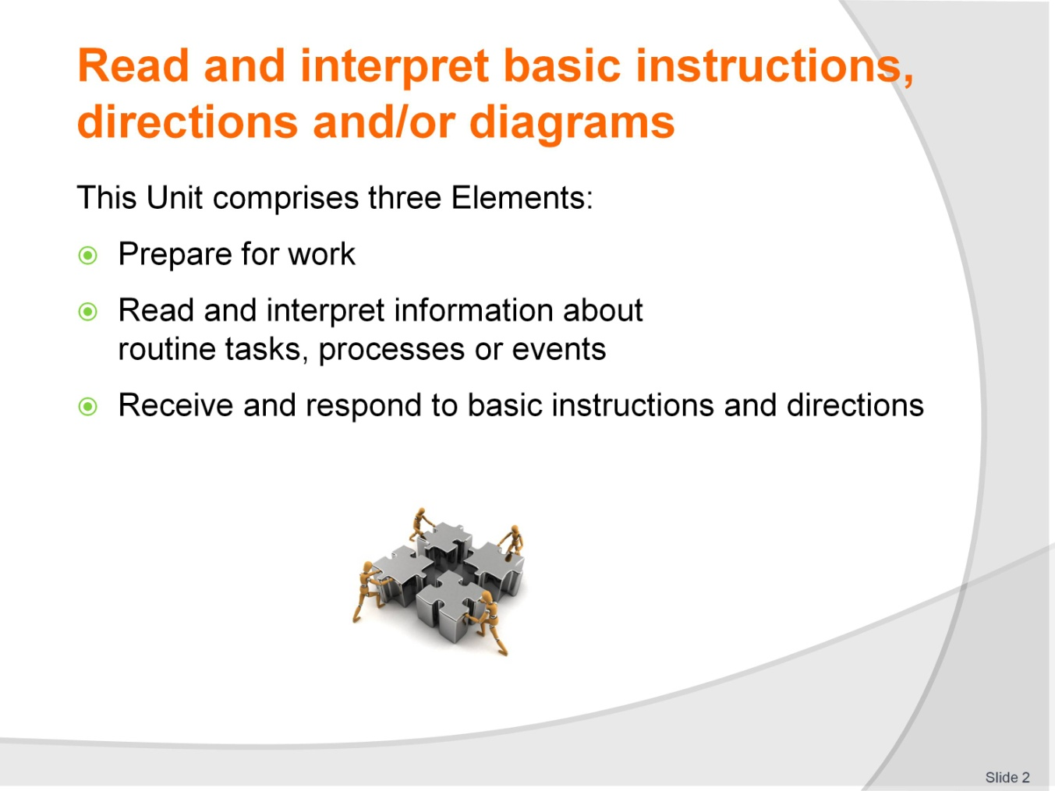
Slide No | Trainer Notes
Trainer advises students this Unit comprises three Elements, as listed on the slide explaining:
Each element comprises a number of Performance Criteria which will be identified throughout the class and explained in detail
Students can obtain more detail from their Trainee Manual
The course presents advice and information but where their workplace requirements differ to what is presented, the workplace practices and standards must be observed.

Slide
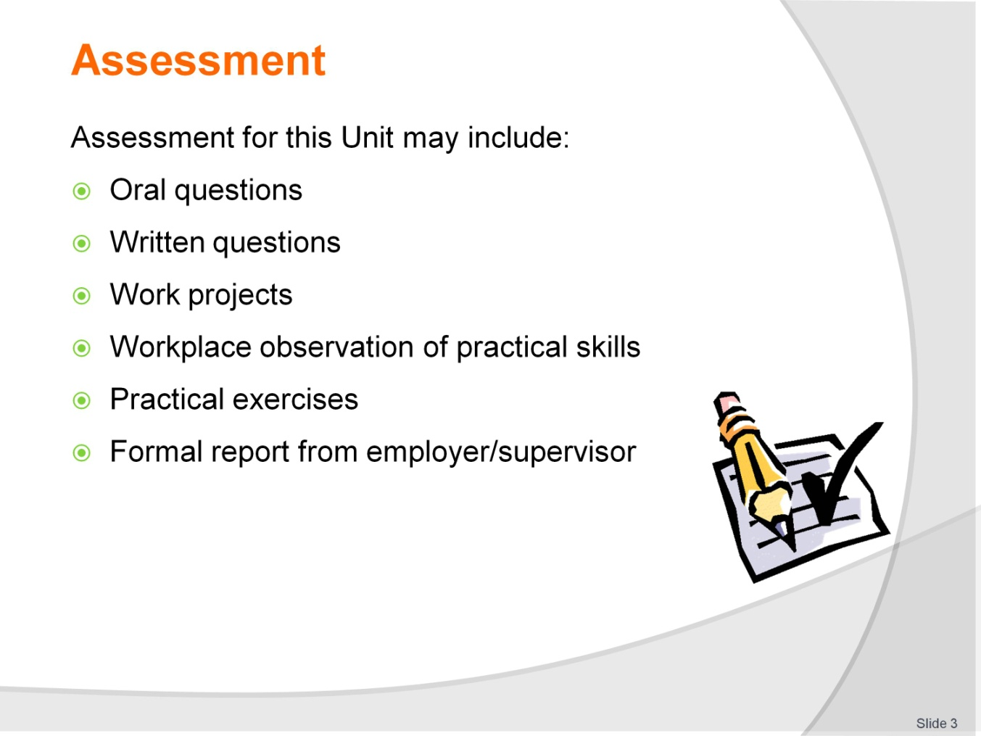
Slide No | Trainer Notes
Trainer advises students that assessment for this Unit may take several forms, all of which are aimed at verifying they have achieved competency for the Unit as required.
Trainer indicates to students the methods of assessment that will be applied to them for this Unit.

Slide
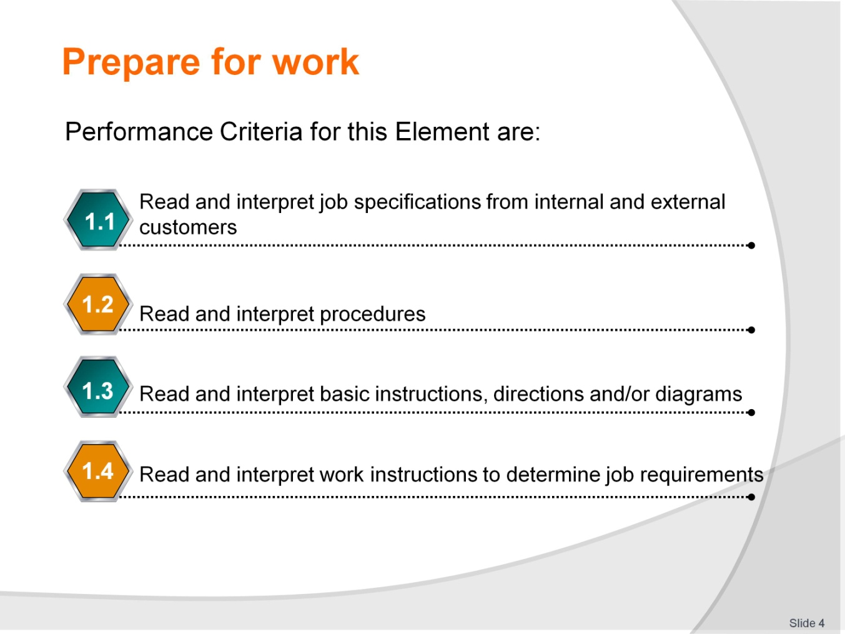
Slide No | Trainer Notes
Trainer identifies the Performance Criteria for this Element, as listed on the slide.
Class Activity – General discussion
Trainer leads a general class discussion on how students usually prepare for work.

Slide
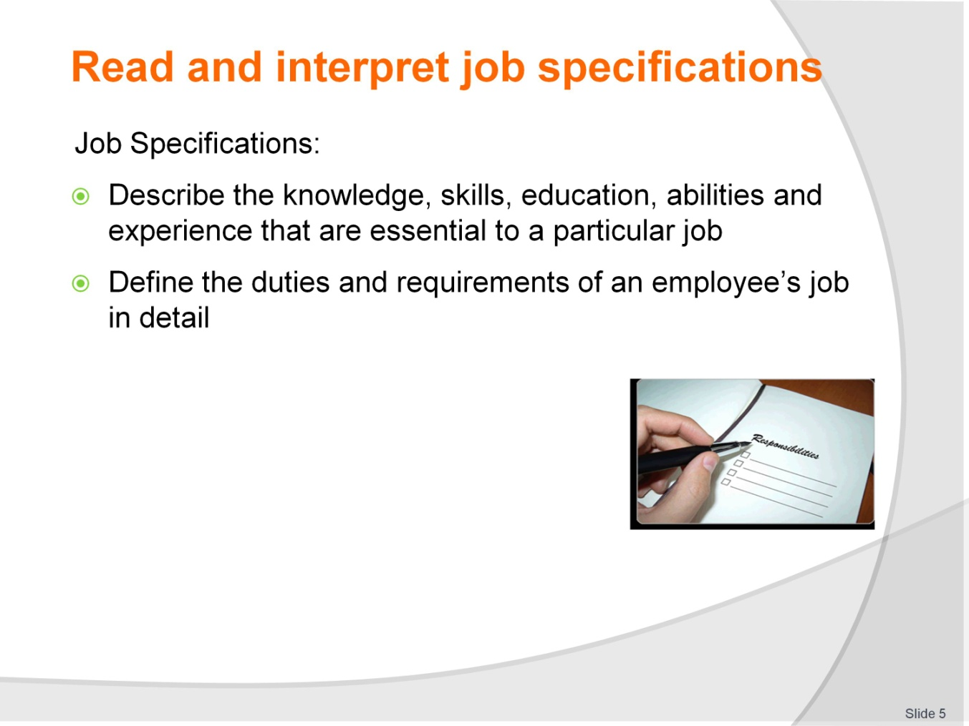
Slide No | Trainer Notes
Trainer provides the definition of job specifications. Trainer asks why it’s important to understand job specifications.
Speaking Activity – Class
Trainer asks students to brainstorm jobs that are involved in hospitality.

Slide
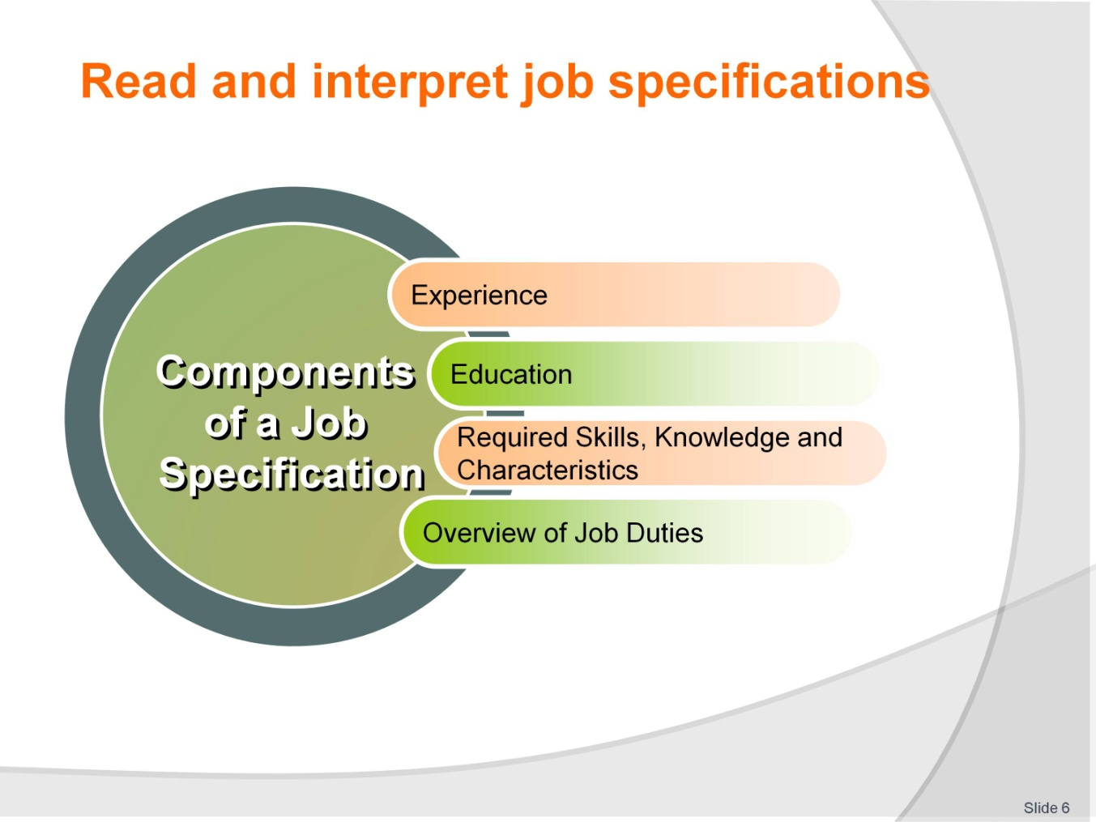
Slide No | Trainer Notes
Trainer discusses the components of a job specification:
Experience
Education
Required Skills, Knowledge and Characteristics
Overview of Job Duties.
Writing Activity – Individual
Trainer instructs students to read a list of attributes and group them into the specific component of a job specification.
Speaking Activity – Class
Trainer leads a discussion about which position the job description is for.

Slide

Slide No | Trainer Notes
Writing Activity – Individual
Trainer instructs students to read a list of attributes and group them into the specific component of a job specification.
Analytical Activity – Individual
Trainer instructs students to analyse the job description and decide what other positions this candidate would be suitable for.
Writing Activity – Individual
Trainer instructs students to write down four jobs in their workplace and list two attributes that would be suitable for each position.

Slide
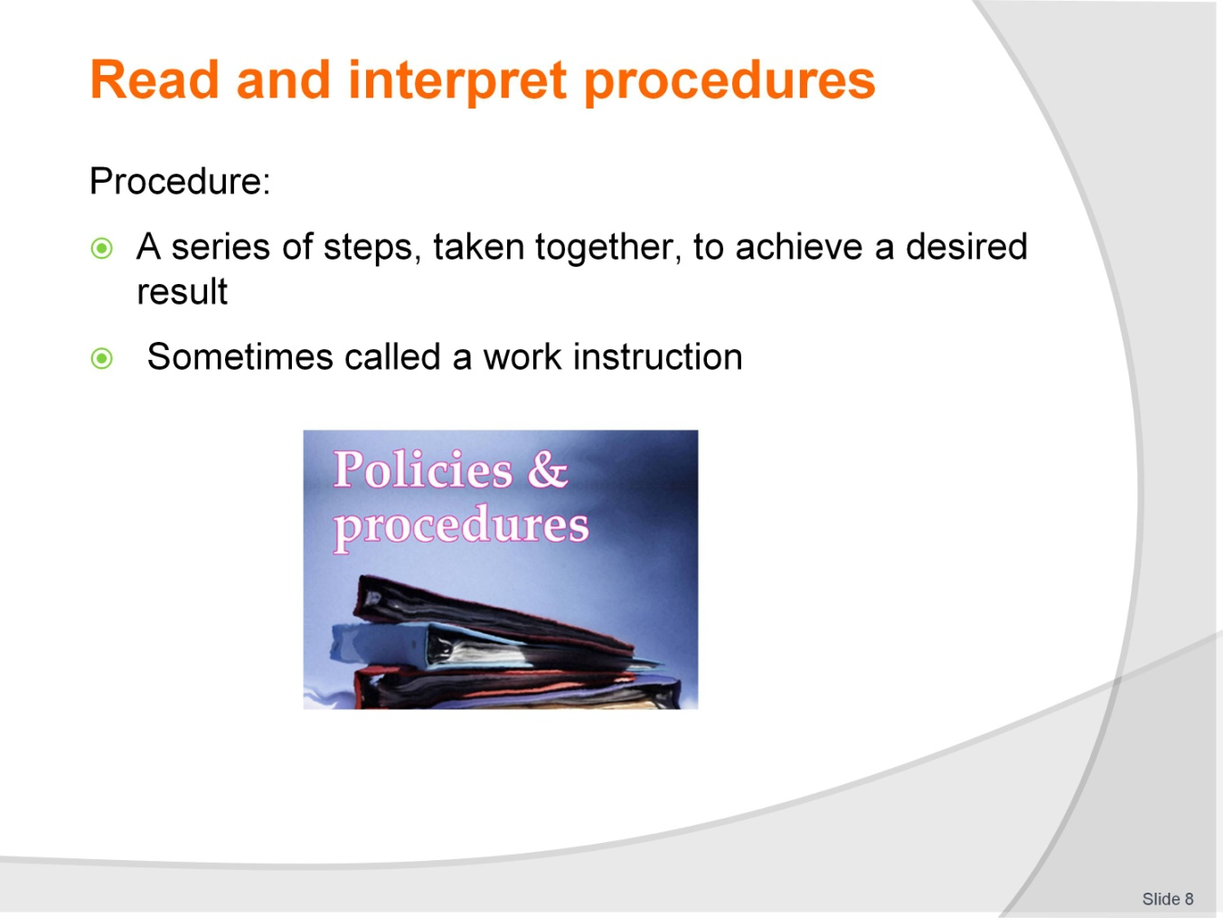
Slide No | Trainer Notes
Trainer opens the conversation by asking what the students would do if there were a fire in the building? He/She then asks the following questions:
How would you know what to do?
Is there a plan?
What would happen if there were no plan?

Slide
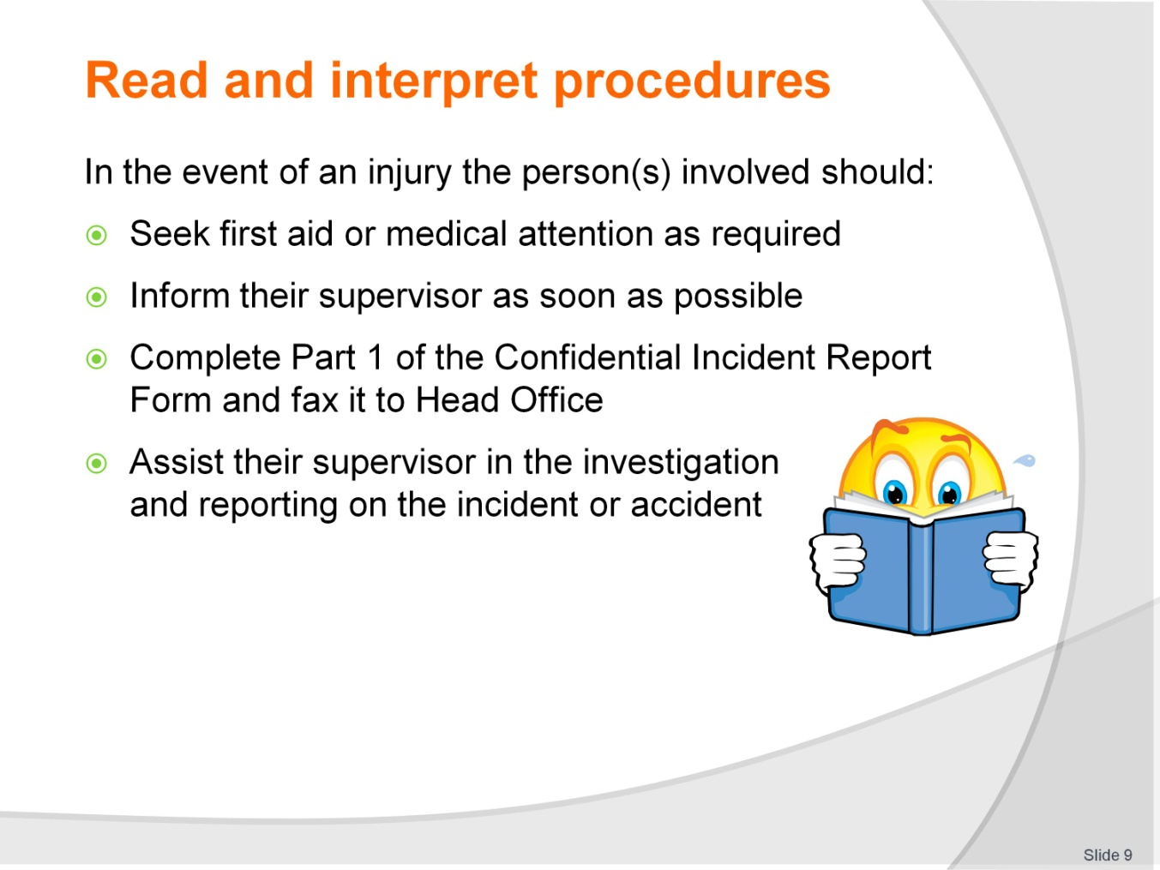
Slide No | Trainer Notes
Reading Activity – Individual
Trainer instructs students to read the evacuation procedure and discuss their own evacuation procedure.
Writing Activity – Individual
Trainer instructs student to read a procedure and answer 10 questions.

Slide
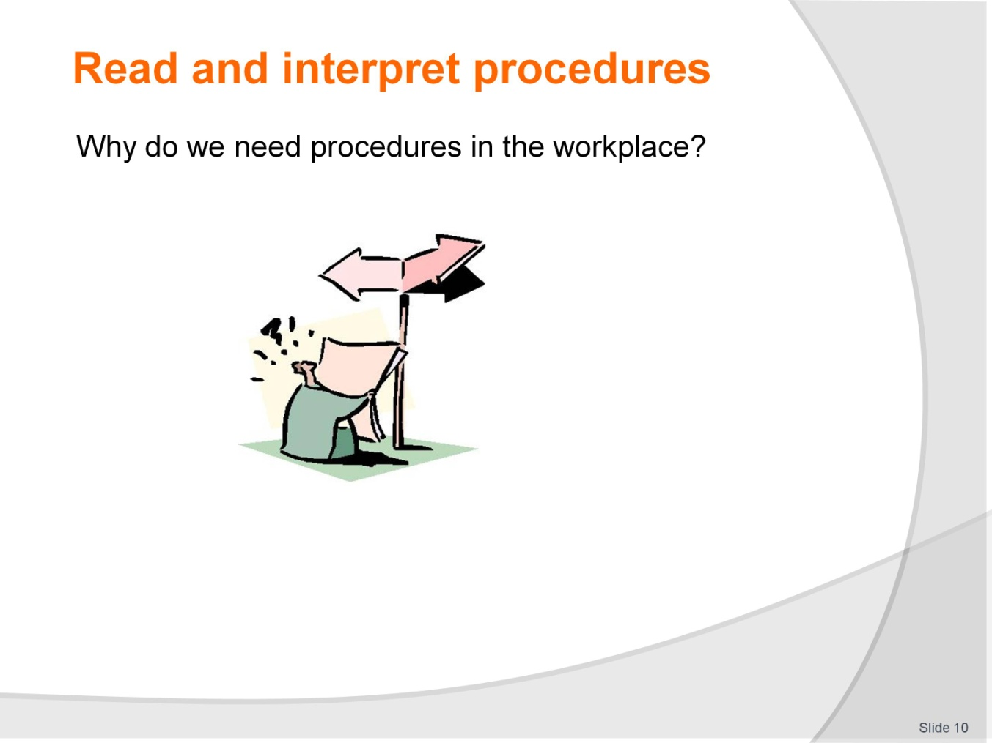
Slide No | Trainer Notes
Group Activity
Trainer instructs students to complete four activities in their Trainee Manual.
Speaking Activity – Class
Trainer leads a discussion about why procedures are needed in the workplace.

Slide
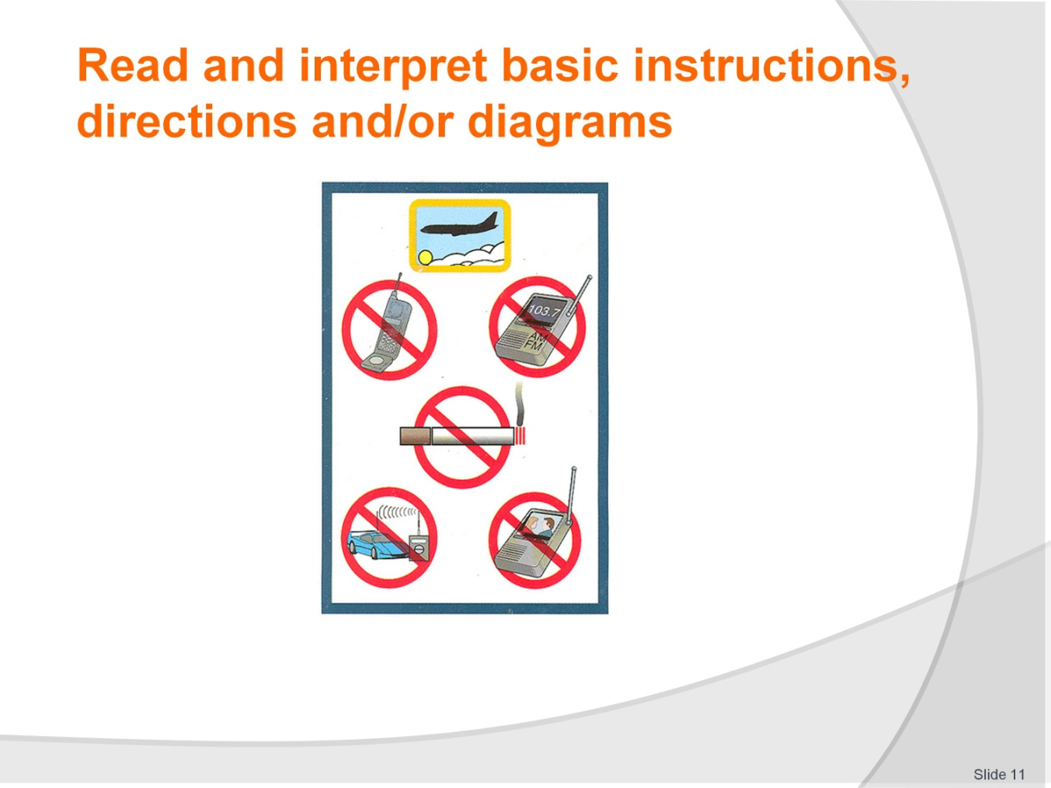
Slide No | Trainer Notes
Speaking Activity – Class
Trainer asks students the following questions:
What is the purpose of this picture?
Who is the giver of this information?
Who is the receiver of this information?
What is this picture telling you to do/not to do?
What are the six symbols in this picture?
What do the red circles with a line through them represent?
What does the yellow border of the top picture represent?
Why is this picture important?

Slide
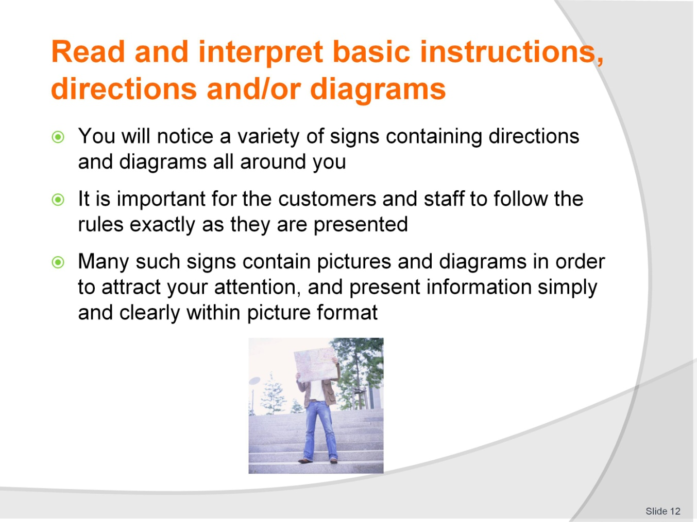
Slide No | Trainer Notes
Trainer leads a discussion about the importance of understanding diagrams and directions/instructions.
Speaking Activity – Class
Trainer instructs students to refer to their Trainee Manuals and asks students the following questions:
Who are these directions for?
What kind of industry would have a sign like this?
Have you ever seen similar signs before, and when?
What does this sign mean?
What actions would you take to follow these directions?

Slide
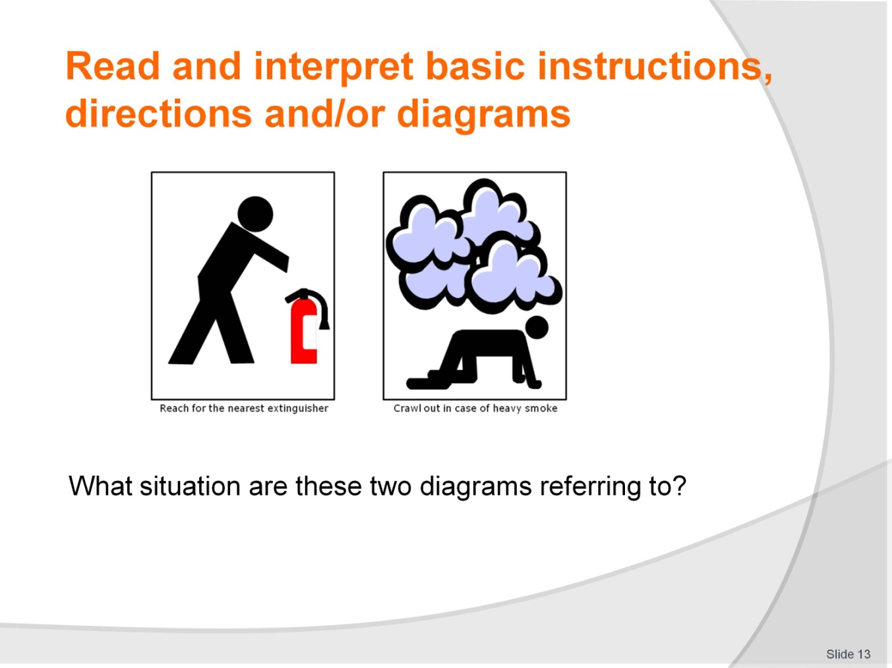
Slide No | Trainer Notes
Analytical Activity – Individual
Trainer instructs students to work in their Trainee Manuals to analyse a diagram and draw their own diagrams.

Slide
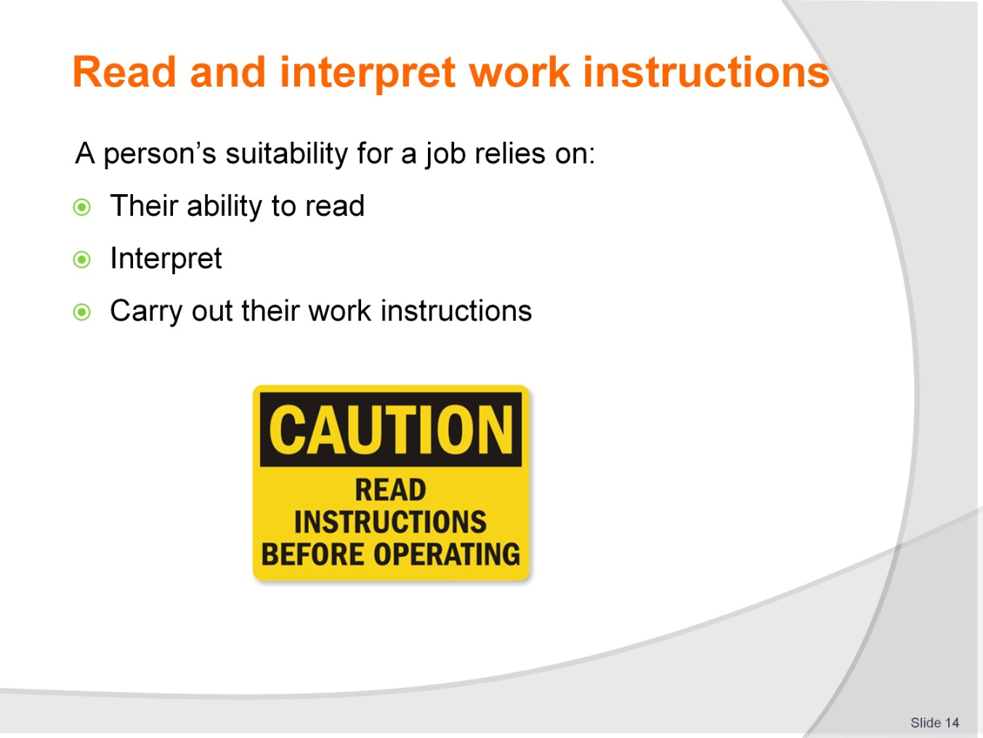
Slide No | Trainer Notes
Trainer provides students with a printout of complicated instructions (any topic related to hospitality) and asks the students start the job.
Speaking Activity - Class
Trainer asks students why the activity was difficult for them and what they can do to better understand instructions.

Slide
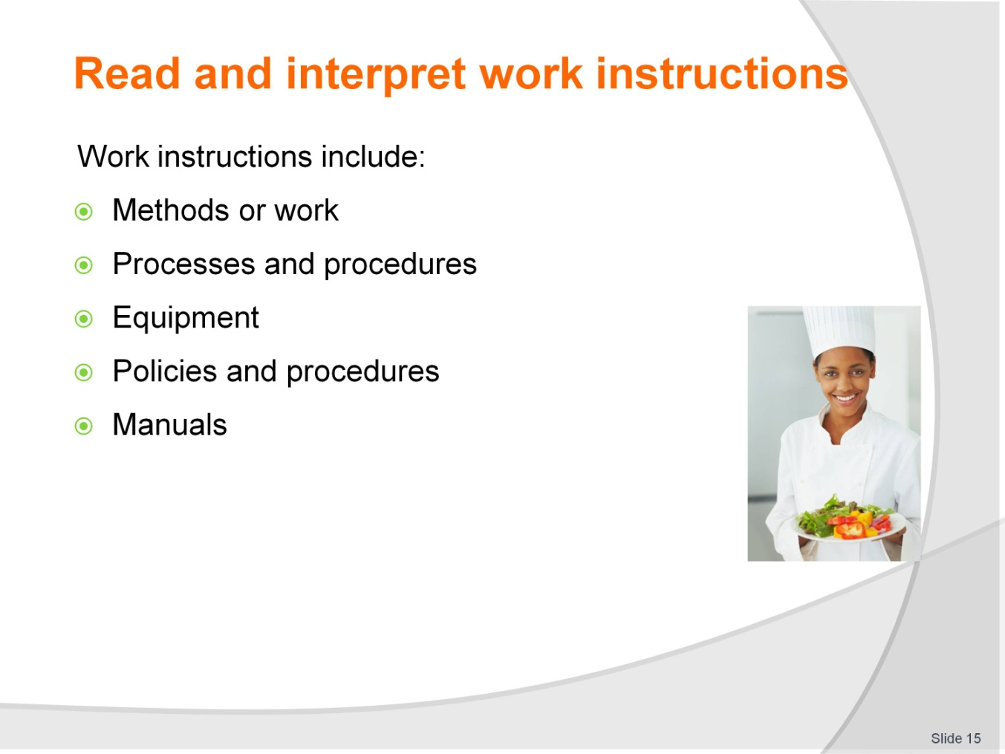
Slide No | Trainer Notes
Trainer explains the variety of work instructions the students will see, including:
Methods or work processes and procedures, equipment policies and procedures manuals.

Slide
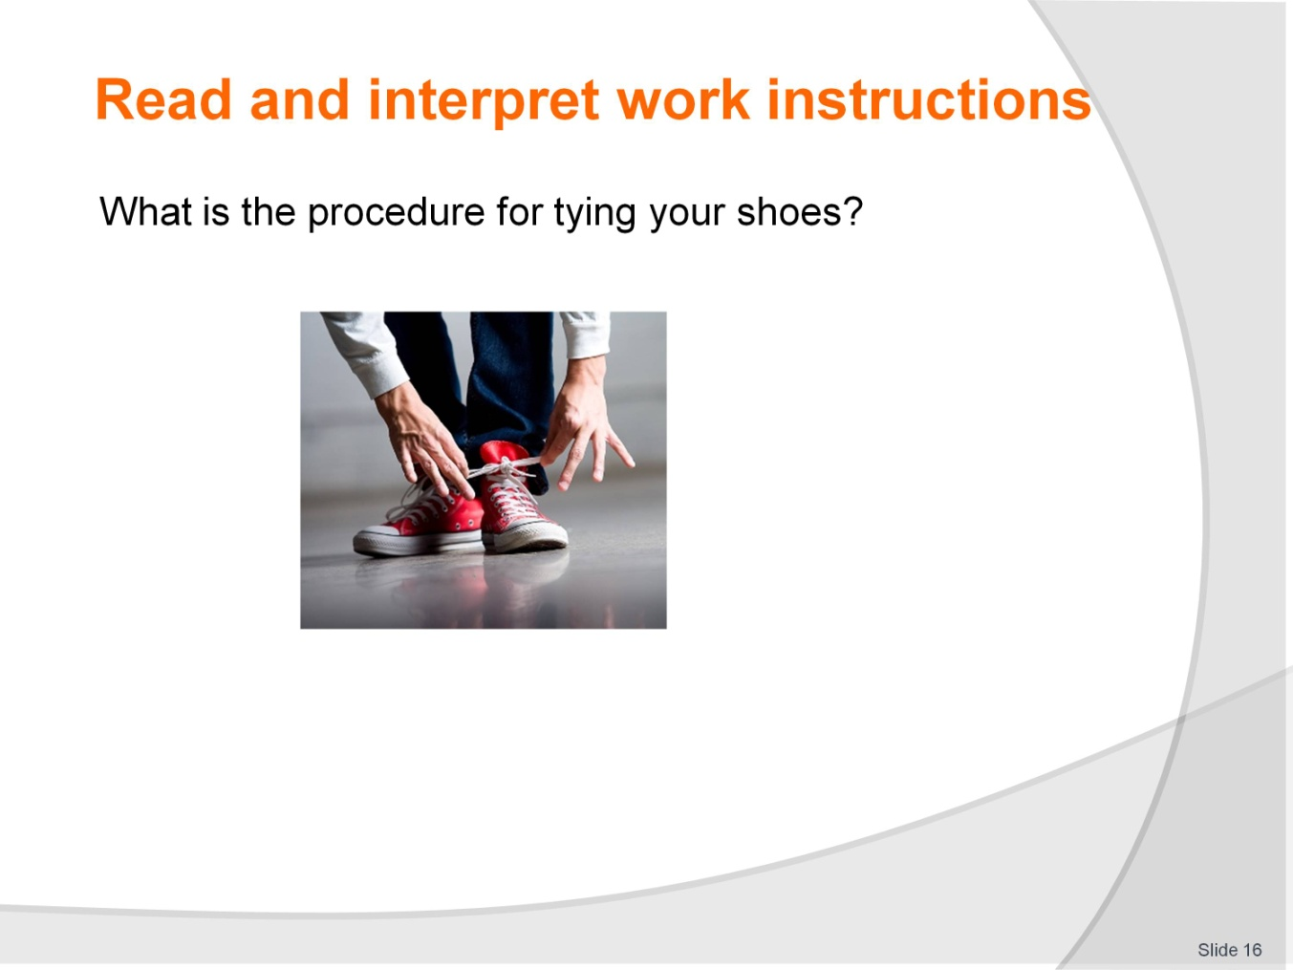
Slide No | Trainer Notes
Writing Activity – Individual
Trainer asks students to look at pictures in the Trainee Manual and write simple instructions to do the job.
Writing Activity – Individual
Trainer asks students to read instructions in their Trainee Manual and re-order them.
Writing Activity – Partner
Trainer asks students to work as partners to read scenarios in their Trainee Manuals and decide which set of instructions they will need for each.

Slide
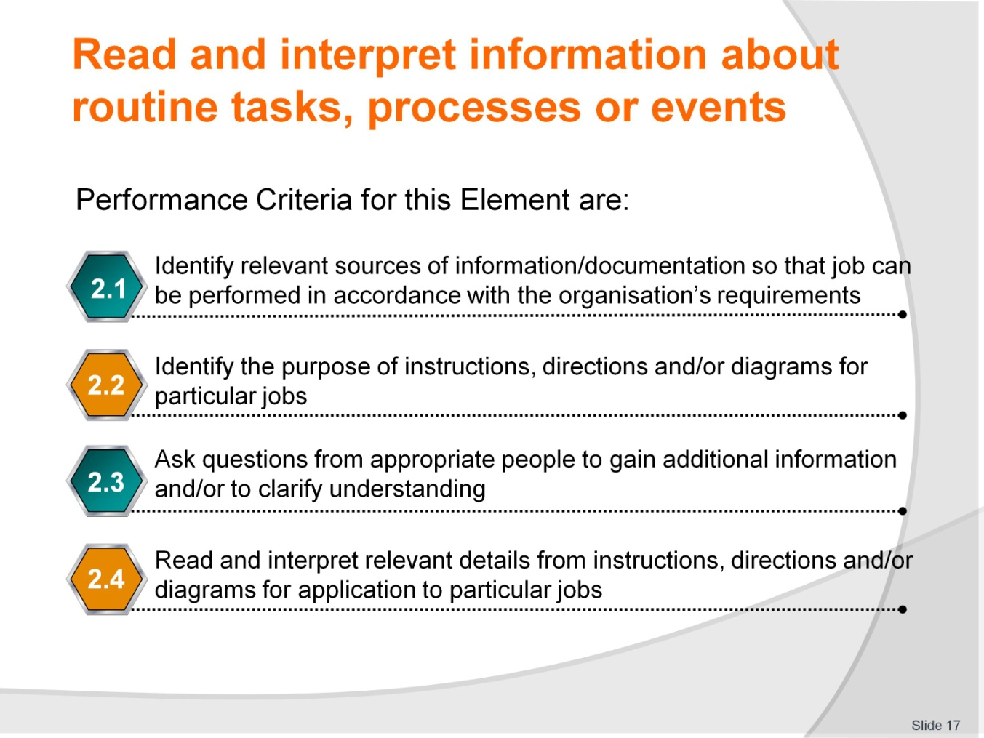
Slide No | Trainer Notes
Trainer identifies the Performance Criteria for this Element, as listed on the slide.
Class Activity – General discussion
Trainer leads a general class discussion on interpreting information, asking questions such as:
How do you interpret directions?
What are a few strategies that can help you understand directions more clearly?

Slide
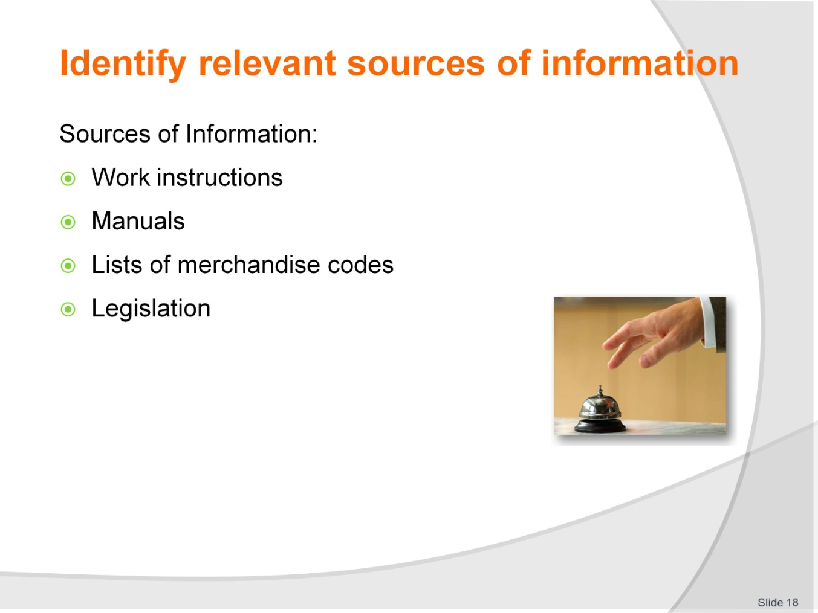
Slide No | Trainer Notes
Trainer starts a discussion about where the students find information they need. He/She describes the following sources:
Work instructions, manuals, lists of merchandise, codes, legislation.

Slide
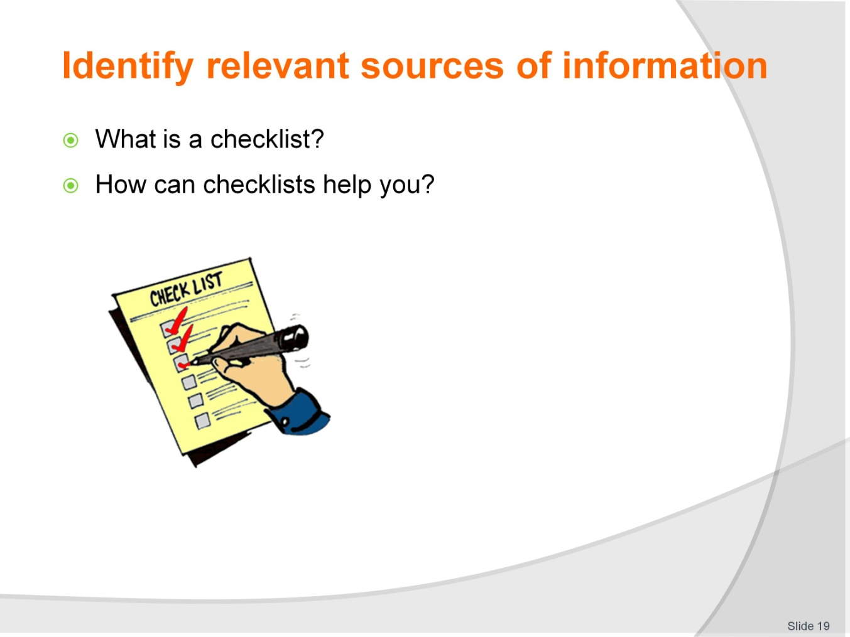
Slide No | Trainer Notes
Trainer starts a discussion about checklists using the questions on the slide.
Writing Activity – Individual
Trainer asks students to write a checklist for their job.
Matching Activity – Individual
Trainer asks students to match the pictures to sources of information in their Trainee Manual.

Slide
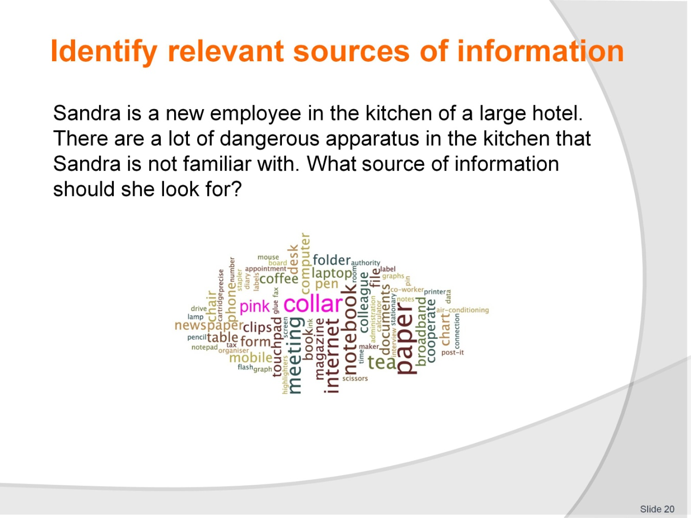
Slide No | Trainer Notes
Writing Activity – Individual
Trainer asks students to read the scenarios listed in the Trainee Manual and identify the appropriate sources of information they will need.
Speaking Activity – Class
Trainer asks students to discuss what sources of information they find in their workplace.

Slide
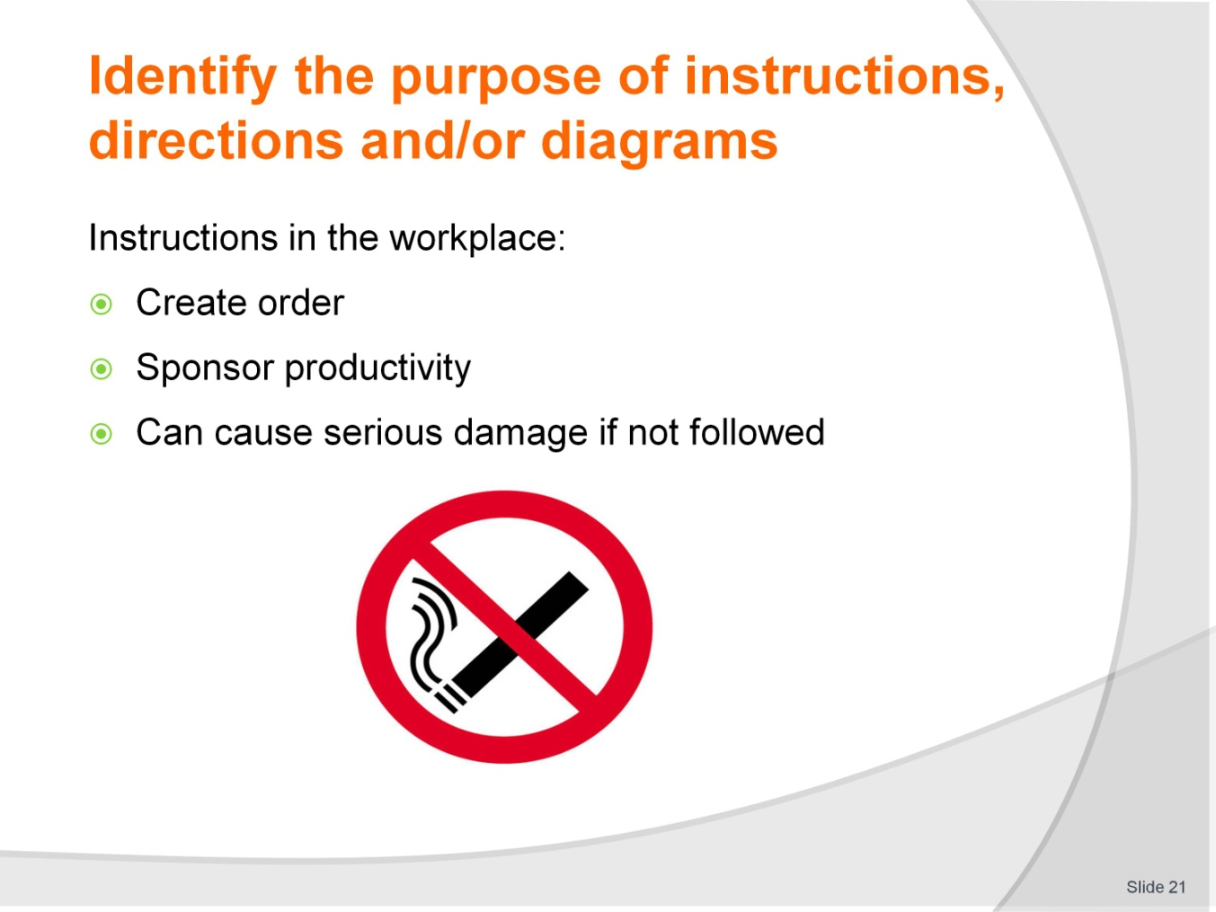
Slide No | Trainer Notes
Trainer leads a discussion about instructions in the workplace using the points listed on the slide.
Speaking Activity – Class
Trainer asks students to choose one sign in the Trainee Manual and answer the questions about the sign. They should discuss their answers with the class.

Slide
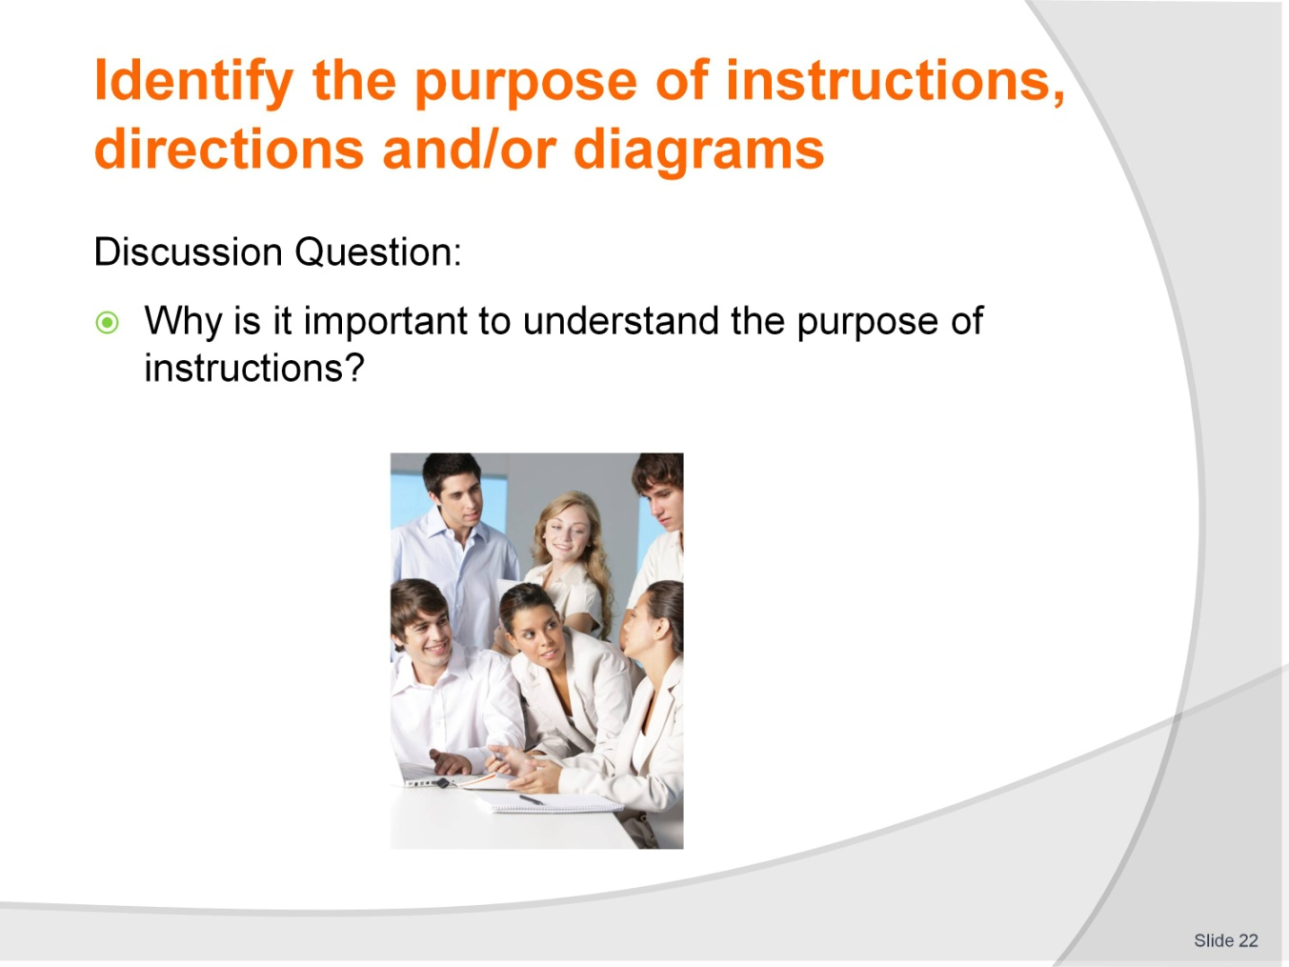
Slide No | Trainer Notes
Trainer leads a discussion about the purpose of instructions in the workplace using the question listed on the slide.
Writing Activity – Individual
Trainer asks students to interpret the instructions in their Trainee Manual and complete the chart.

Slide
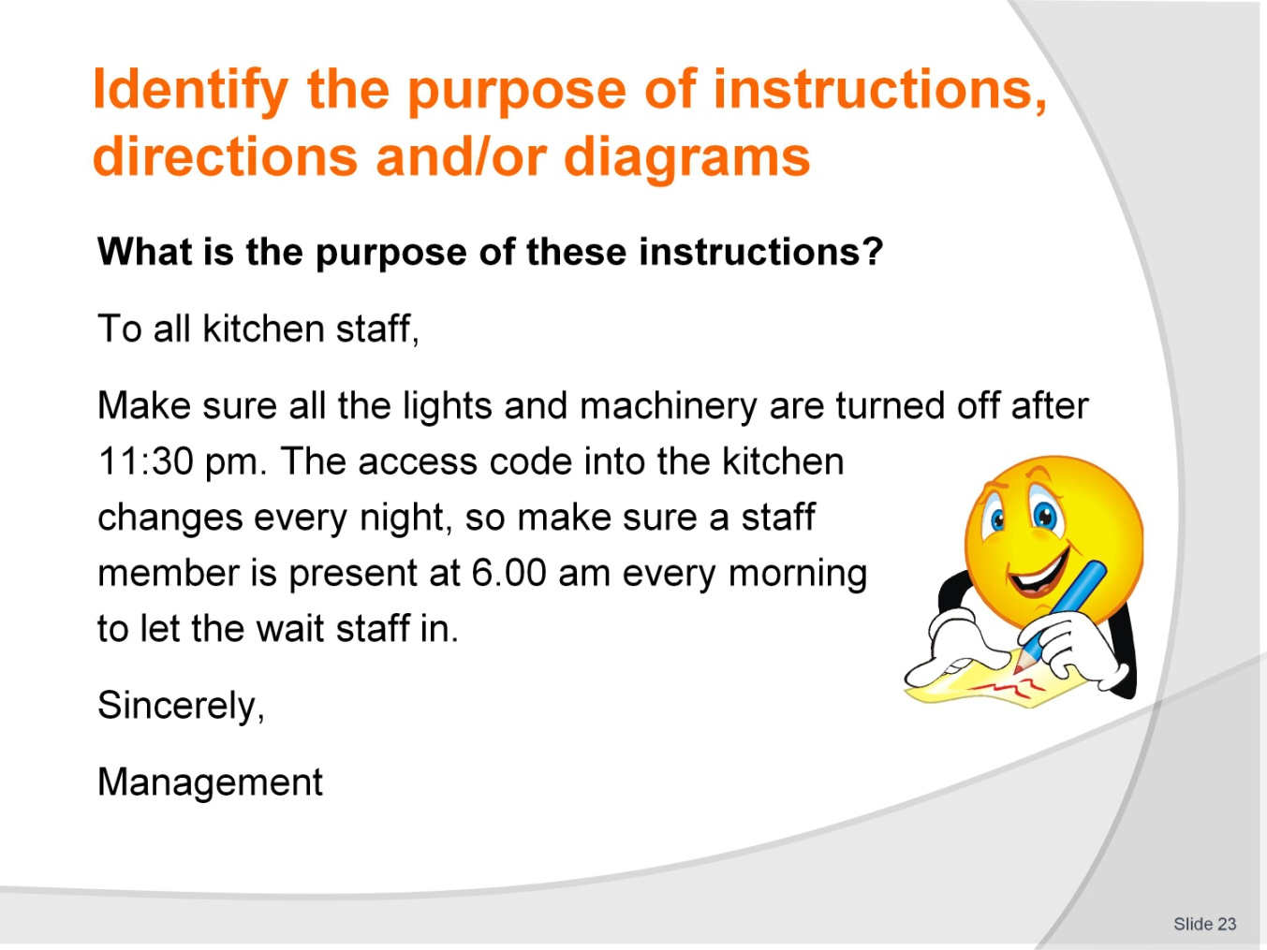
Slide No | Trainer Notes
Trainer leads a discussion about the instructions on the slide.
Analytical Activity – Individual
Trainer instructs students to read scenarios in their Trainee Manual and answer the questions about them.

Slide
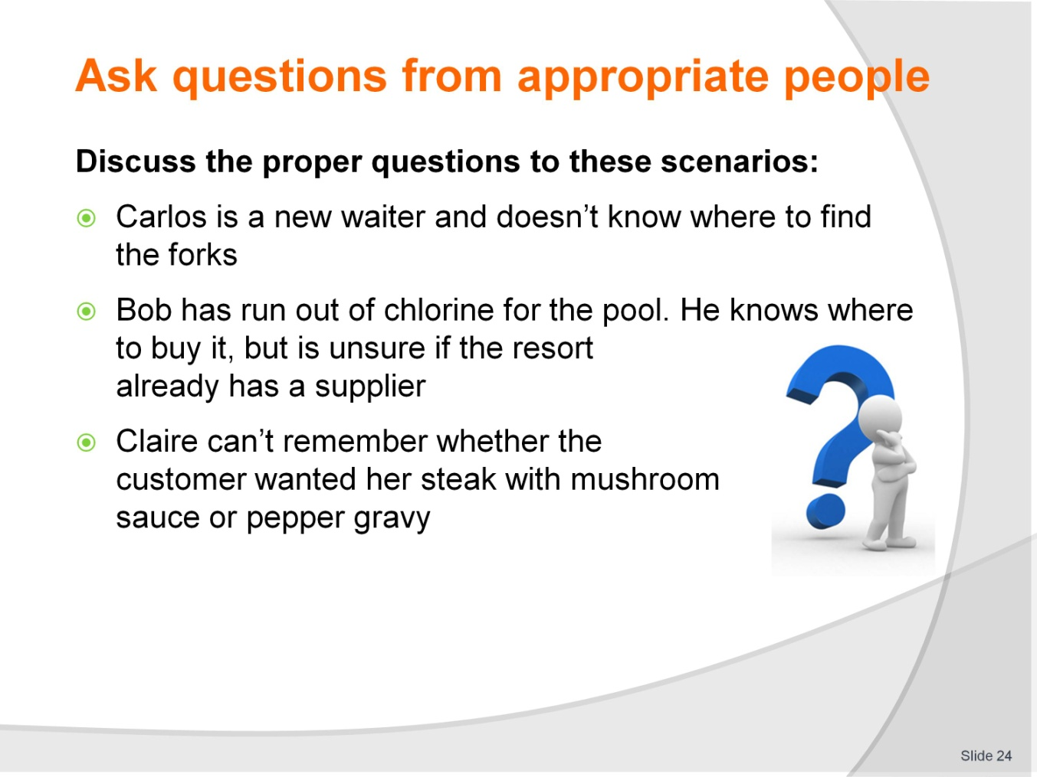
Slide No | Trainer Notes
Trainer introduces the topic by asking the students to form questions for the scenarios on the slide.
Writing Activity – Individual
Trainer asks students to read the scenarios in their Trainee Manual and write the proper question for each.

Slide

Slide No | Trainer Notes
Trainer discusses appropriate people on the slide.
Speaking Activity – Group
Trainer asks students to brainstorm other appropriate people at their workplace.

Slide
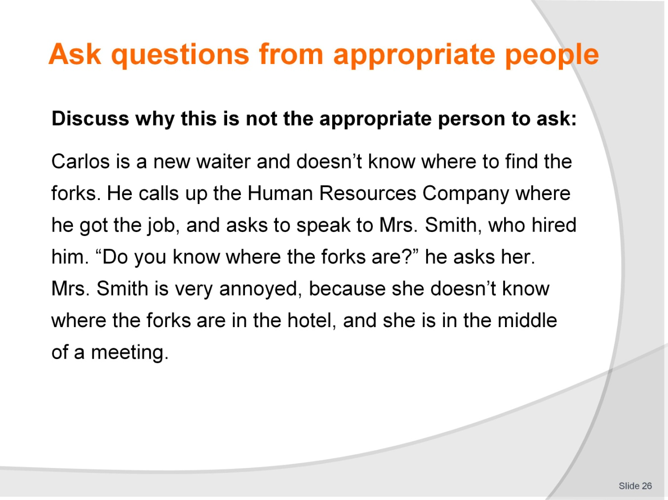
Slide No | Trainer Notes
Critical Thinking Activity – Class
Trainer and students discuss the scenarios listed in the Trainee Manual and talk about why these people are inappropriate to ask about them.
Critical Thinking Activity – Class
Trainer and students discuss the scenarios listed in the Trainee Manual and talk about appropriate people to ask about them.
Speaking Activity – Class
Trainer divides the class up, so that a group consists of five to six students each representing a type of person: supervisors/managers, co-workers, colleagues, human resource personnel, clients and members of the public. Ask a question to each, and have each student answering exactly as they imagine the type of person they represent would respond. As a group, the students decide who was the best person to ask.

Slide
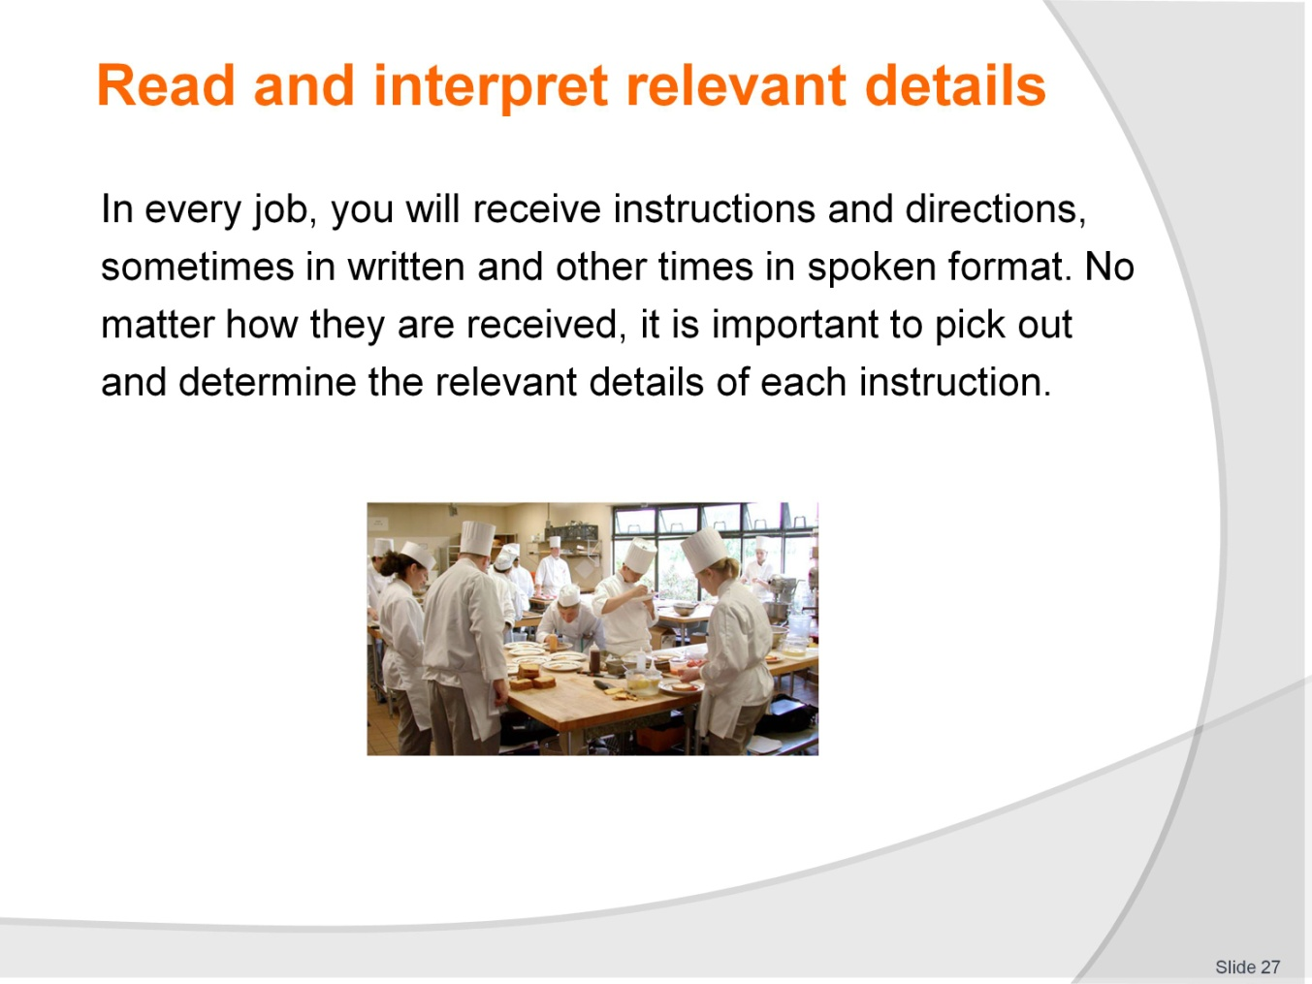
Slide No | Trainer Notes
Trainer leads a discussion about relevant details and asks students to pick out relevant details from the slide.
Speaking Activity – Class
Trainer leads a discussion about the value of understanding relevant details.

Slide
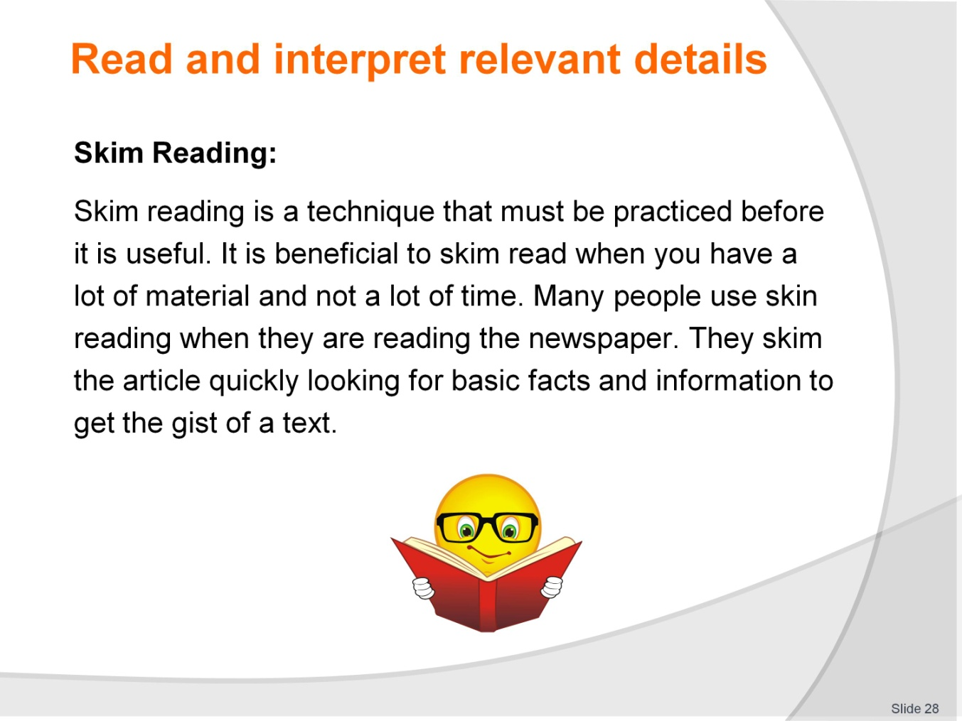
Slide No | Trainer Notes
Trainer explains skim reading to the students.
Reading Activity – Individual
Trainer instructs students to find a document in English, skim it, and tell the class what they read about.

Slide
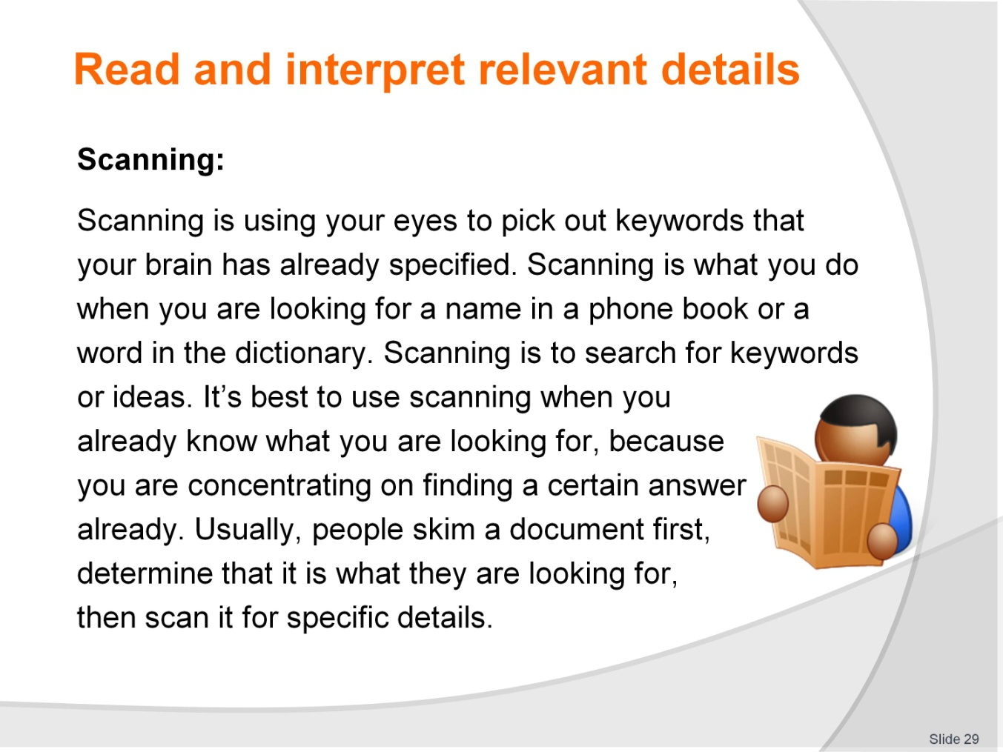
Slide No | Trainer Notes
Trainer explains scanning to the students.
Reading Activity – Individual
Trainer instructs students to scan the same document they used for skimming and describe the difference.
Reading Activity – Individual
Trainer instructs students to read an email and note in their Trainee Manuals and scan them for relevant details.

Slide
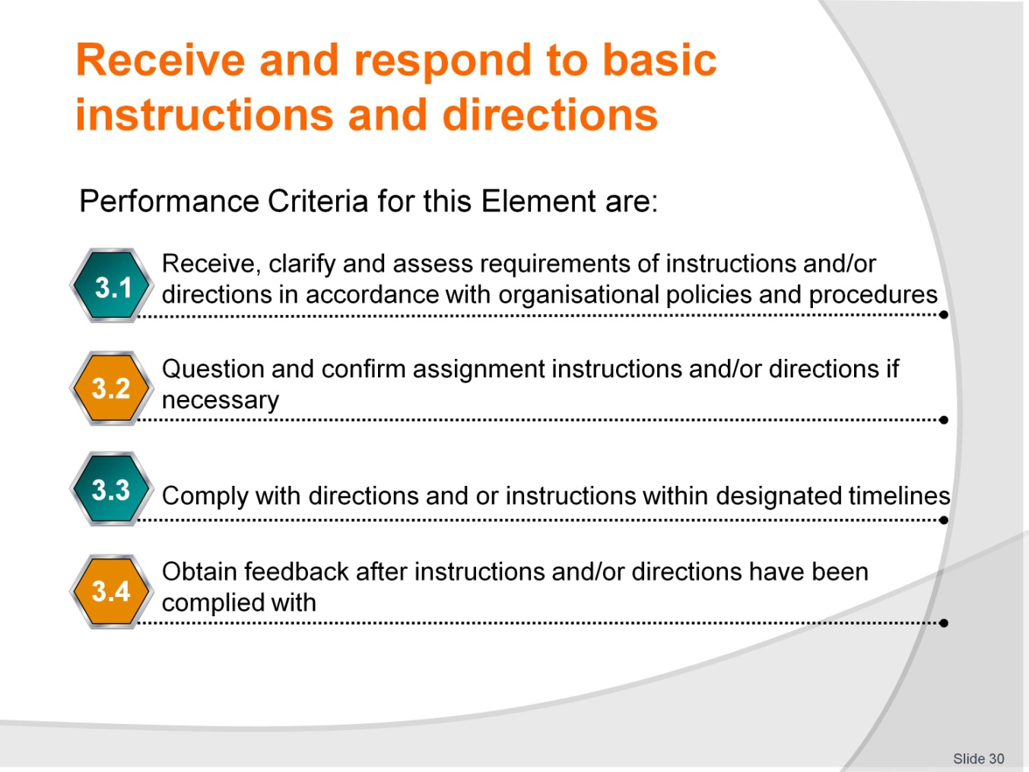
Slide No | Trainer Notes
Trainer identifies the Performance Criteria for this Element, as listed on the slide.
Class Activity – General discussion
Trainer leads a general class discussion on responding to instructions and requests, asking questions such as:
What does ‘instructions’ mean?
What kind of requests do you get at your job?
How do you respond to these requests?

Slide
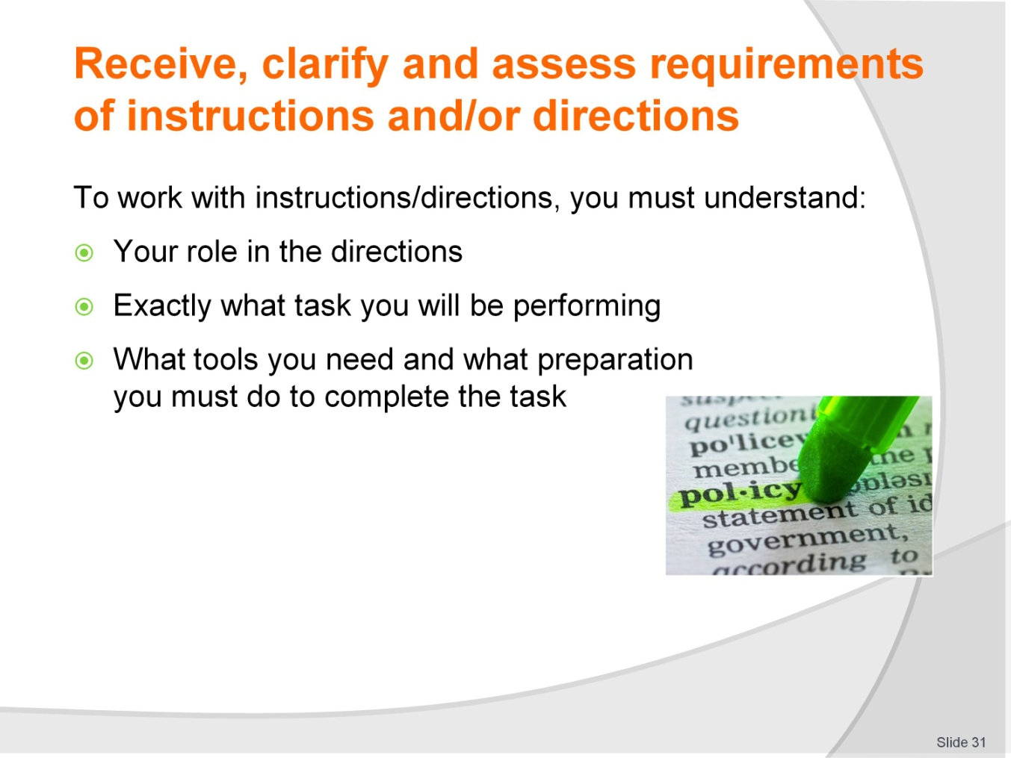
Slide No | Trainer Notes
Trainer explains the best way to work with instructions using the points on the slide.
Reading Activity – Individual
Trainer instructs students to read an email in their Trainee Manuals
Writing Activity – Individual.
Trainer instructs students to answer questions about the email.
Speaking Activity – Individual
Trainer instructs students to read a checklist of activities and decide which can be delegated to Melissa’s staff.

Slide
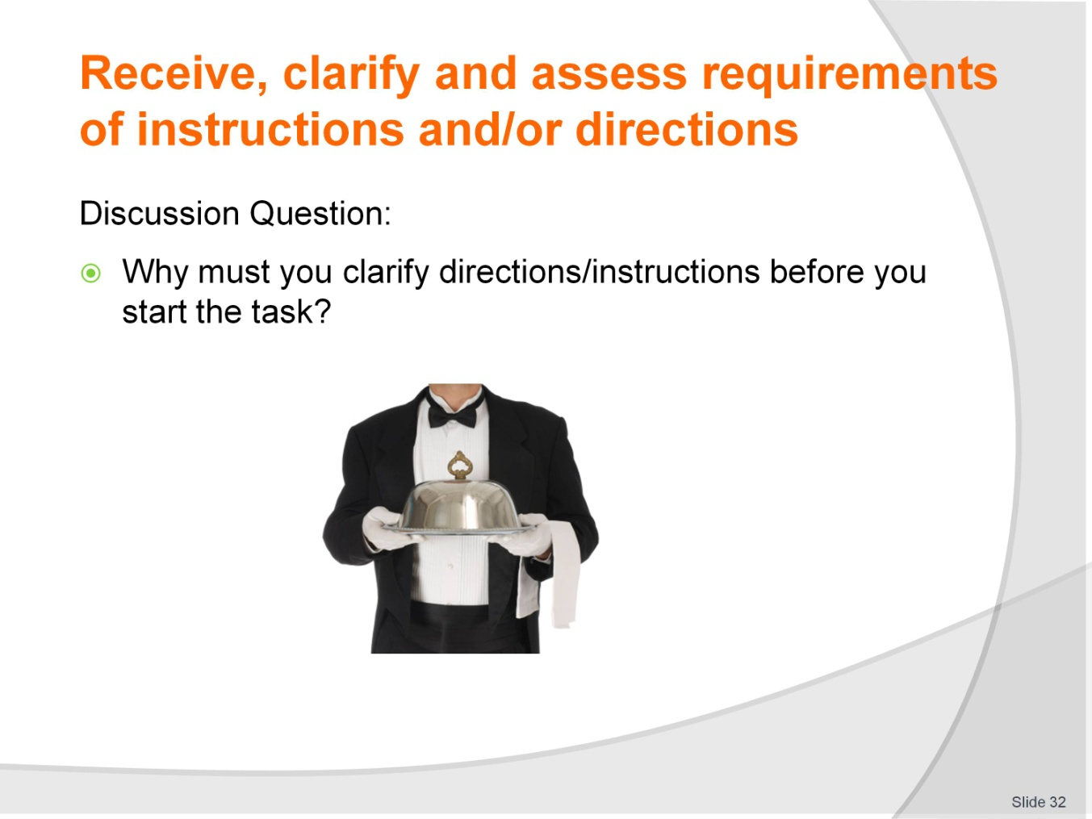
Slide No | Trainer Notes
Trainer starts a discussion using the question on the slide.
Reading Activity – Individual
Trainer instructs students to read a letter in their Trainee Manuals and answer questions about the instructions in the letter.
Writing Activity – Individual
Trainer instructs students to create a checklist for Pedro.

Slide
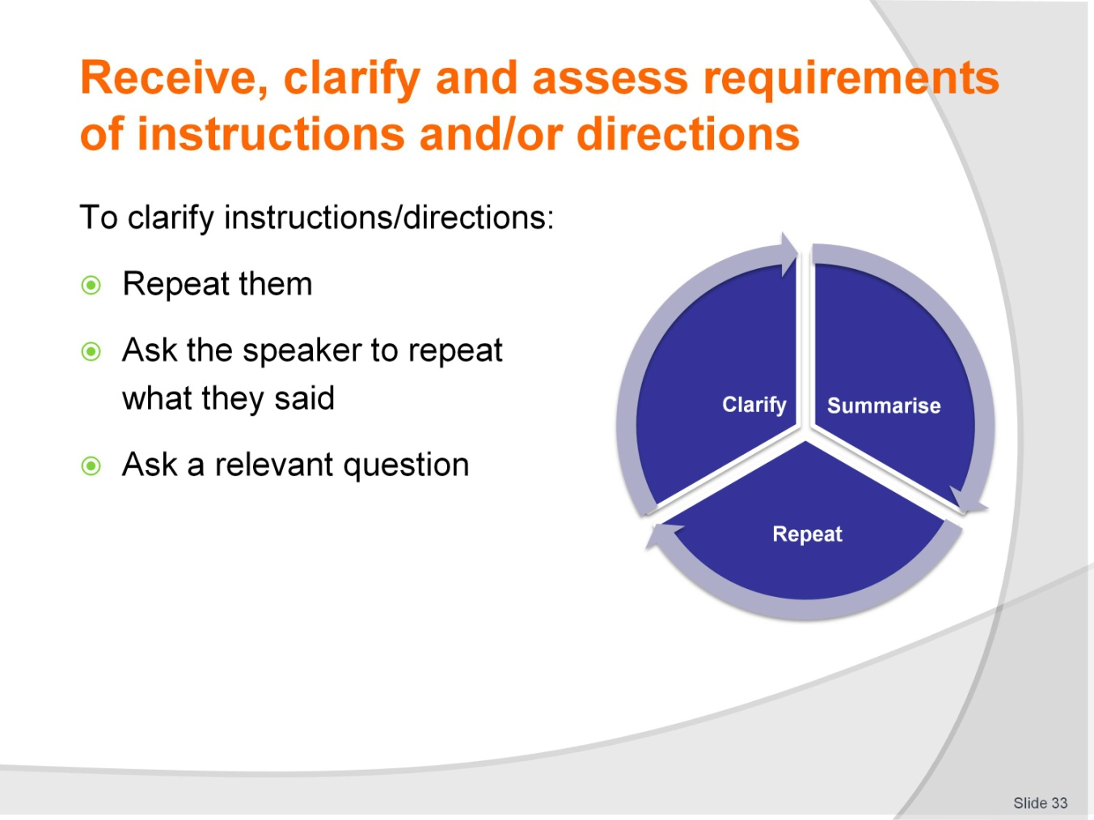
Slide No | Trainer Notes
 | Trainer gives students a complicated set of instructions, speaking as quickly as possible. He/She pays attention to their responses and calls out if anyone asks for clarification. Trainer then starts a conversation about clarifying instructions using the points in the slide.

Slide
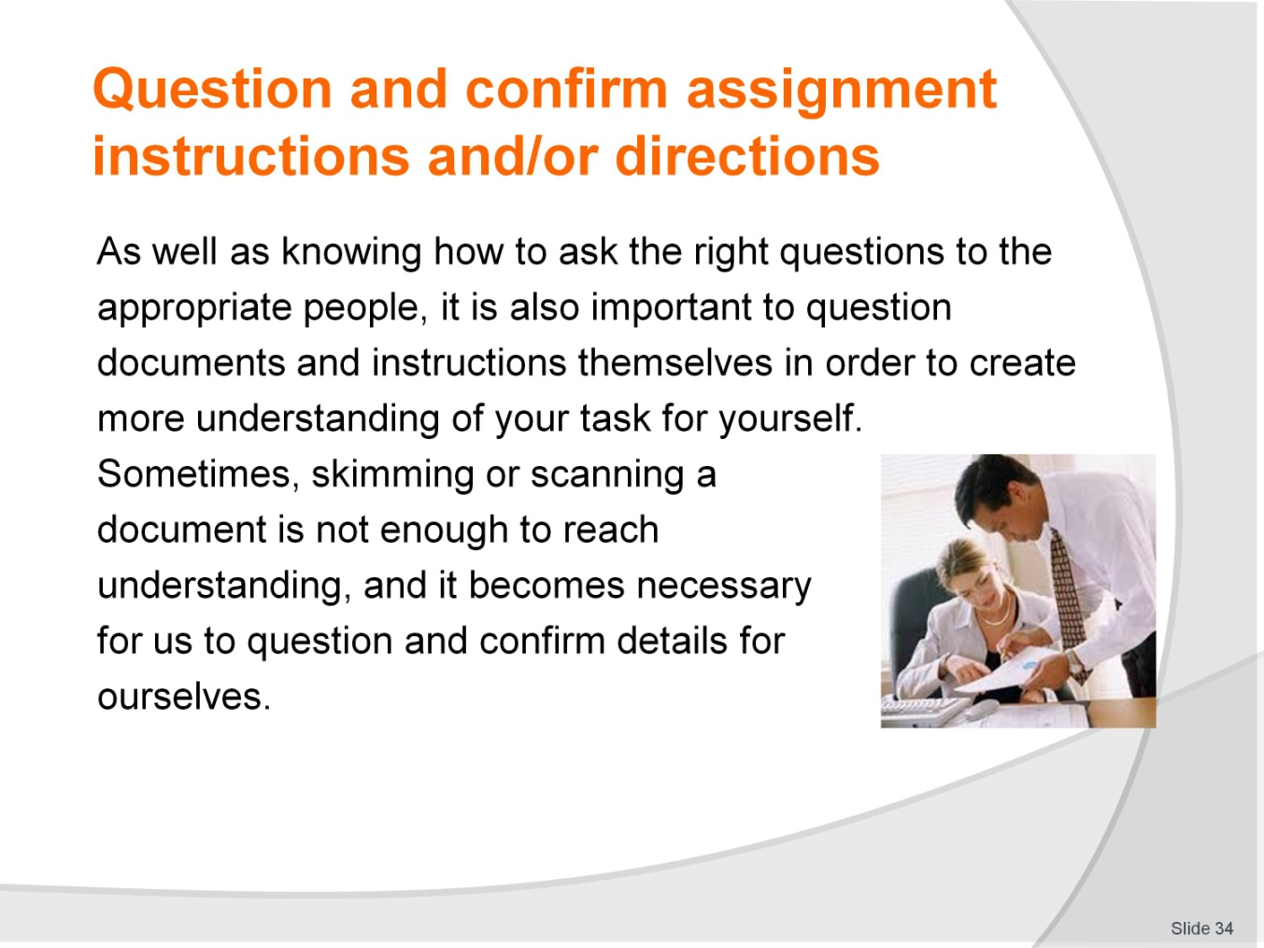
Slide No | Trainer Notes
 | Trainer starts a discussion about confirming instructions/directions using the points on the slide.

Slide

Slide No | Trainer Notes
Reading Activity – Individual
Trainer instructs students to read a case study in their Trainee Manual and answer the questions about it.
Writing Activity – Individual
Trainer instructs students to read a memo in their Trainee Manual and answer the questions about it.
Writing Activity – Individual
Trainer instructs students to read a procedure in their Trainee Manual and answer the questions about it.

Slide
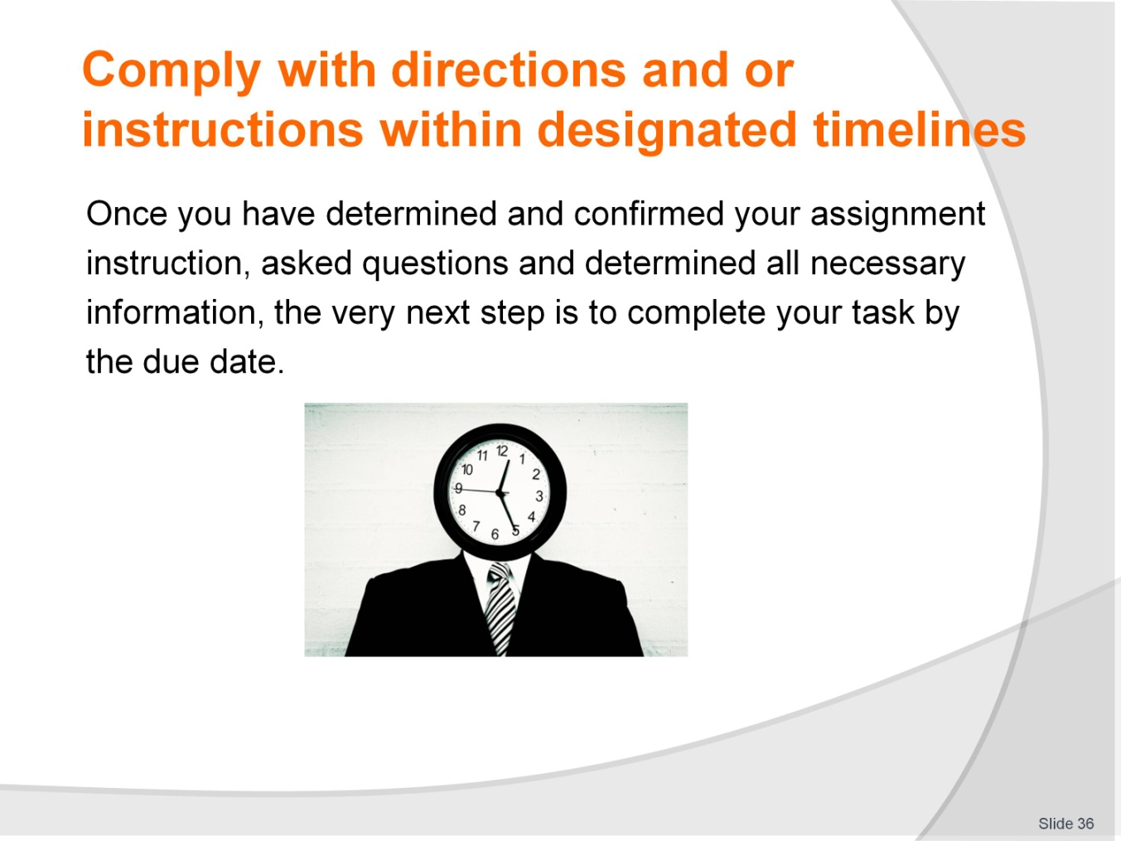
Slide No | Trainer Notes
 | Trainer leads a discussion about how students feel about deadlines. He/She also brings up cultural expectations about meeting deadlines.

Slide
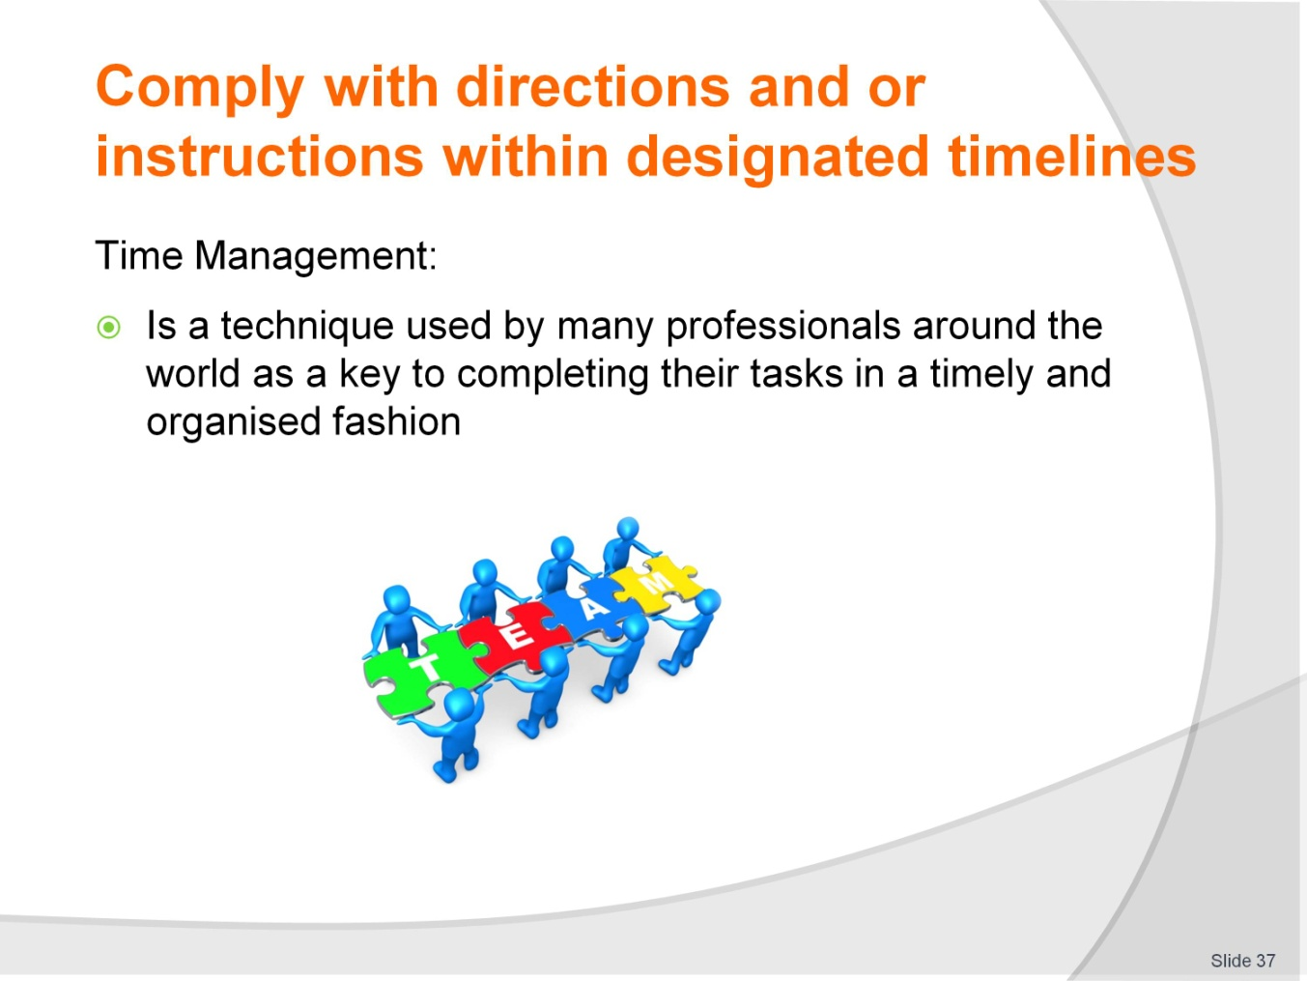
Slide No | Trainer Notes
 | Trainer asks the students what they think about Time Management and why it is important in the workplace.

Slide
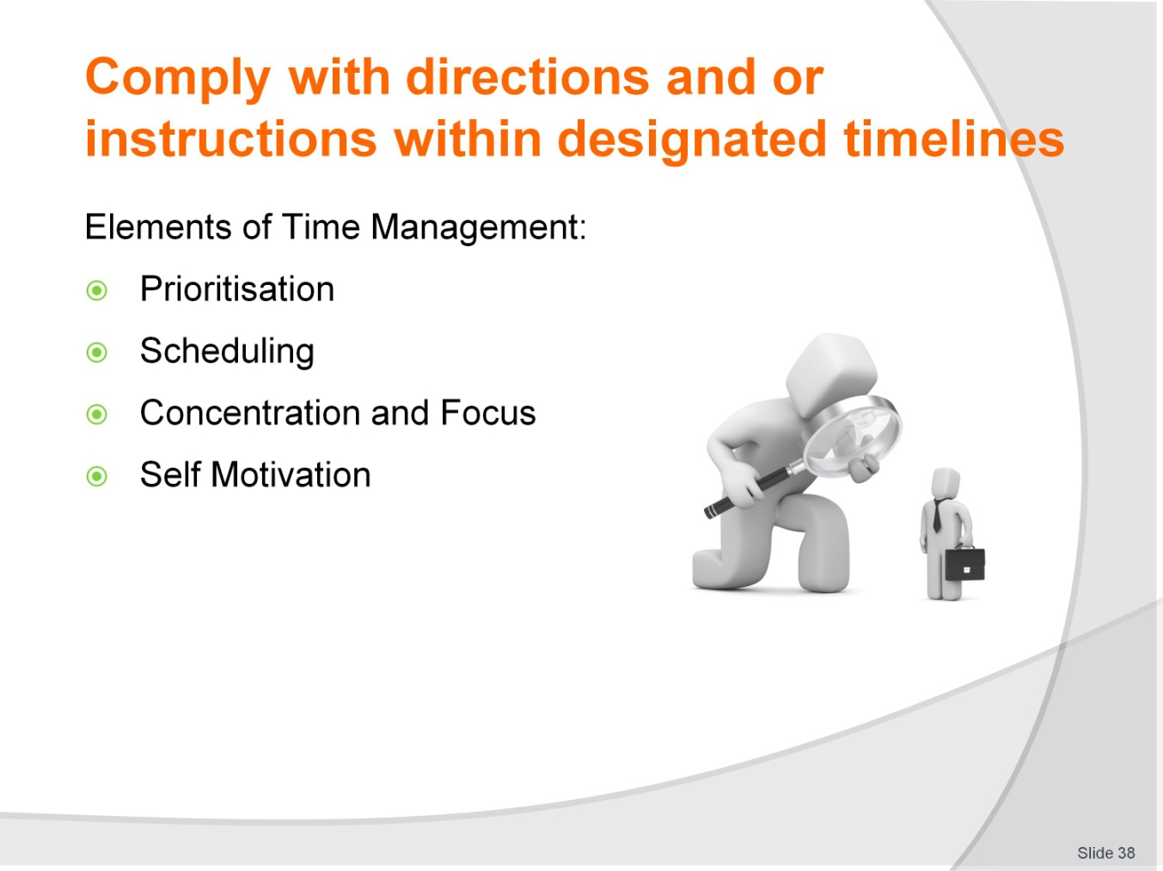
Slide No | Trainer Notes
Trainer explains the elements of Time Management, using the Trainee Manual as a guide.
Analytical Activity – Individual
Trainer instructs students to analyse themselves and answer questions in their Trainee Manual.

Slide

Slide No | Trainer Notes
Trainer leads a discussion about feedback and the importance of obtaining feedback.
Trainer asks the students how they can get feedback. Formally? Informally?

Slide
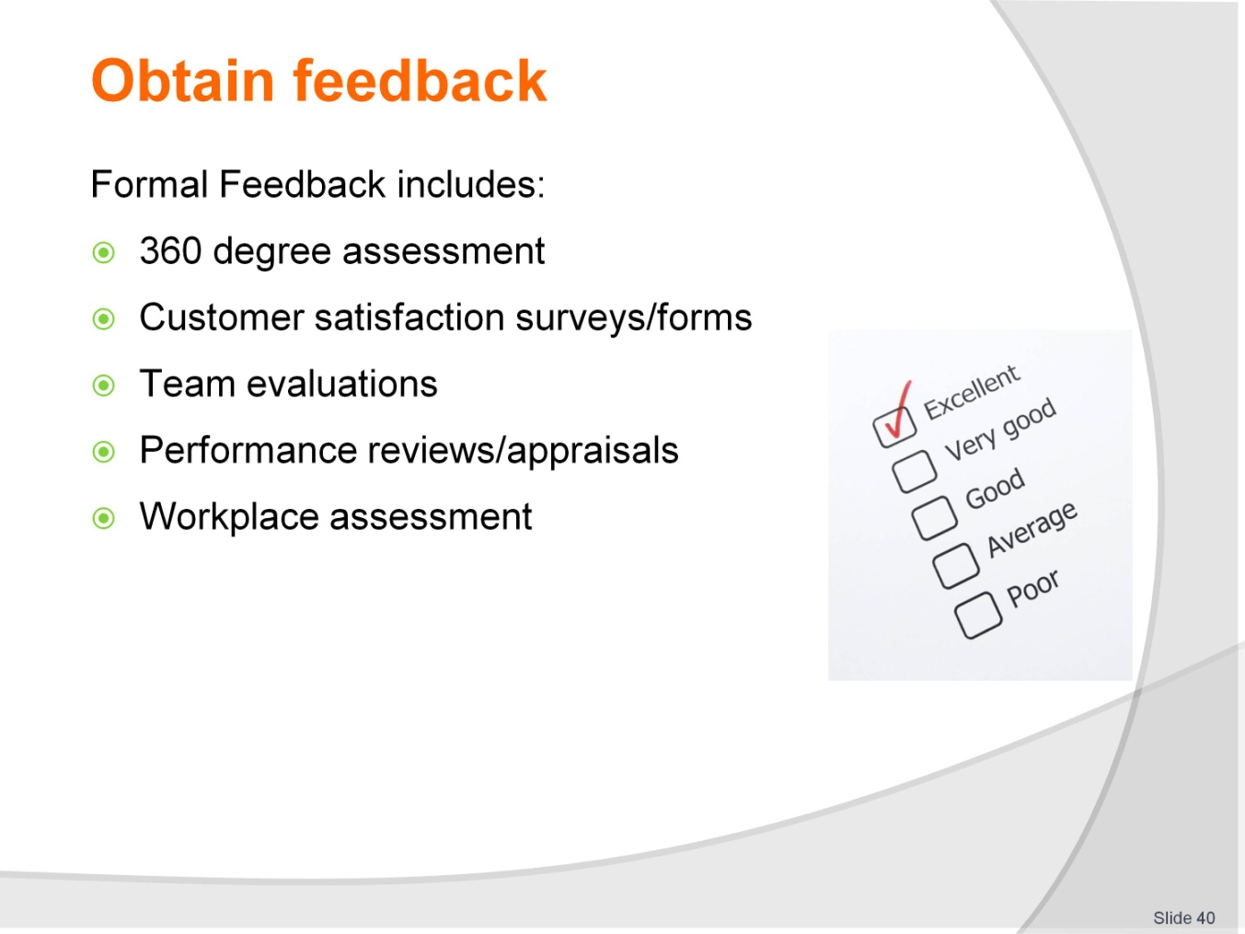
Slide No | Trainer Notes
 | Trainer explains the types of formal feedback listed on the slide.

Slide
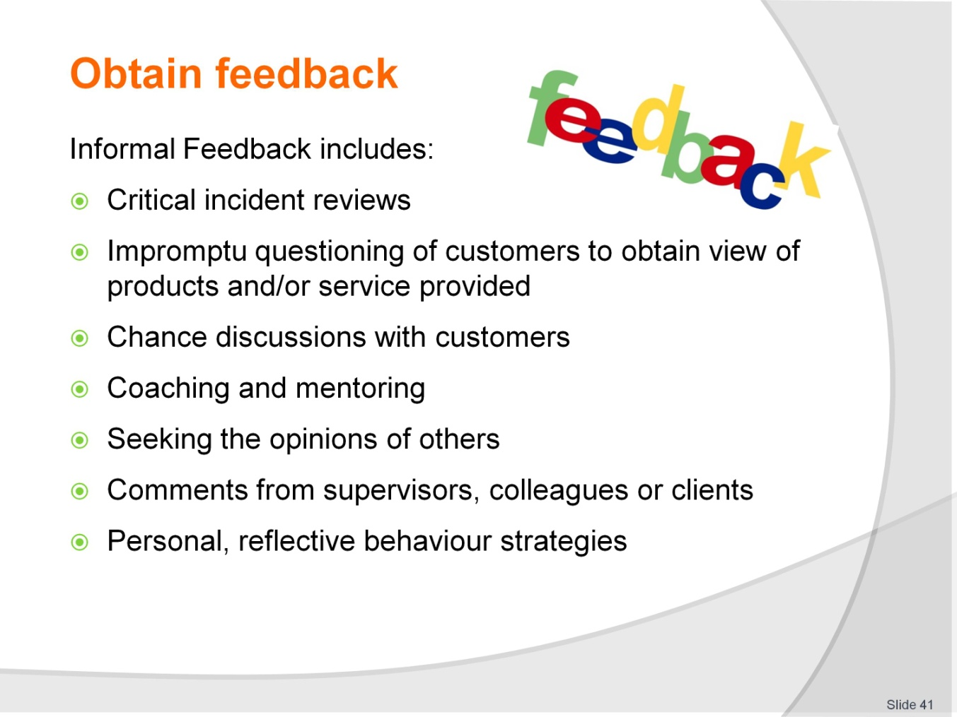
Slide No | Trainer Notes
Trainer explains the types of formal feedback listed on the slide.
Speaking Activity – Class
Trainer instructs students to read and talk about questions listed in their Trainee.

Recommended training equipment
Full range of equipment which may include lap top computer, data projector, overhead projector, white boards, chalk boards, photocopier, DVD player, TV screen, internet access and CD player.
Consumables – such as white board markers and eraser, white board cleaner, overhead pens, transparencies, paper, butcher’s paper, and industry materials relevant to the training topic.
Sample session plans including blank pro-formas and completed examples of session plans for both theory-based and practical training sessions.
Sample training materials such as handouts, case studies, exercises, workplace manuals, workplace policies and procedures, DVD’s, internet downloads, menus, advertising materials, schedules, price lists, brochures.

Instructions for Trainers for using
PowerPoint – Presenter View
Connect your laptop or computer to your projector equipment as per manufacturers’ instructions.
In PowerPoint, on the Slide Show menu, click Set up Show.
Under Multiple monitors, select the Show Presenter View check box.
In the Display slide show on list, click the monitor you want the slide show presentation to appear on.
Source: http://office.microsoft.com
Note:
In Presenter View:
You see your notes and have full control of the presentation
Your trainees only see the slide projected on to the screen
More Information
You can obtain more information on how to use PowerPoint from the Microsoft Online Help Centre, available at: http://office.microsoft.com/training/training.aspx?AssetID=RC011298761033
Note Regarding Currency of URLs
Please note that where references have been made to URLs in these training resources trainers will need to verify that the resource or document referred to is still current on the internet. Trainers should endeavour, where possible, to source similar alternative examples of material where it is found that either the website or the document in question is no longer available online.

Appendix – ASEAN acronyms
AADCP | ASEAN – Australia Development Cooperation Program.
ACCSTP | ASEAN Common Competency Standards for Tourism Professionals.
AEC | ASEAN Economic Community.
AMS | ASEAN Member States.
ASEAN | Association of Southeast Asian Nations.
ASEC | ASEAN Secretariat.
ATM | ASEAN Tourism Ministers.
ATPMC | ASEAN Tourism Professionals Monitoring Committee.
ATPRS | ASEAN Tourism Professional Registration System.
ATFTMD | ASEAN Task Force on Tourism Manpower Development.
CATC | Common ASEAN Tourism Curriculum.
MRA | Mutual Recognition Arrangement.
MTCO | Mekong Tourism Coordinating office.
NTO | National Tourism Organisation.
NTPB | National Tourism Professional Board.
RQFSRS | Regional Qualifications Framework and Skills Recognition System.
TPCB | Tourism Professional Certification Board.







